**Acknowledgements**

**______________________________________________________________________________**

This document has been prepared through the tireless efforts of many individuals, organizations and institutes. Their efforts are deeply appreciated. We specifically acknowledge the efforts of the following individuals who made crucial contribution in creating this document.

* Dr.R.Pararajasegaram & Dr.Bruce Spivey Co-Chairs HRDWG
* Dr. Gullapalli N. Rao President IAPB
* Dr. Mohammad Babar Qureshi, Member HRDWG
* Team at Pakistan Institute of Community Ophthalmology, Peshawar

#### Dr. Ayesha S Abdullah, Faculty member who compiled the report

Dr. Zahid Jadoon, epidemiologist

Mr. Ali Javed Tajik, IT manager

Mr. Nauman Saeed, System Engineer, IT Deptt.

Dr. Naz Jahangir, Research Officer

Mr. Mohammad Omer Abdullah, Faculty member & Research Assit.

* Dr. Khabir Ahmed, Epidemiologist, Agha Khan Medical University
* All the contact and resource persons who were contacted for either data collection or identification of resource persons for the purpose of data collection
* Suzanne Gilbert Secretary HRDWG
* Daksha Patel from International Center For Eye Health London
* Mr. R.D. Thulasiraj, Executive Director LAICO.

&

##### Prof. Mohammad Daud Khan, Rector Khyber Institute of Ophthalmic Medical Sciences

**Contents**

**_______________________________________________________________________________**

i List of abbreviations 4

ii List of Tables 5

iii List of Maps 7

1. Introduction 8

2. Objectives 10

3. Methods 11

4. Results 15

4.1 Regional situation analysis of human resource for eye care 16

4.1.1 Africa 16

4.1.2. Americas 34

4.1.3. Eastern Mediterranean 40

4.1.4. Europe 52

4.1.5. South-East Asia 59

4.1.6. Western Pacific 67

4.2. Training Institutes for Eye-care personnel 83

5. Limitations of the study 90

6. Recommendations 91

7. Annexes 92

Annex 1: Templates 92

Annex 2: Key to the templates 96

Annex 3: List of resource personnel 98

Annex 4: Vision 2020 directory of courses 104

Annex 5:Additional information about training courses 129

8. References 133

# i List of abbreviations

**________________________________________________________________________________**

|  |  |
| --- | --- |
| WPR | Western Pacific Region |
| SEA | South –East Asia |
| EMR | Eastern Mediterranean |
| CEH | Community Eye Health |
| Ophthalmol | Ophthalmologist |
| Optomet | Optometrists |
| WHO | World health Organization |
| NPBC | National Committee for the Prevention of Blindness |
| HMIS | Health Management Information System |
| PICO | Pakistan Institute of Community Ophthalmology |

# ii List of Tables

**______________________________________________________________________________**

Table 1 Spectrum of Categories for categories for the availability of human resource 13

Table 2 Regional Summary of Africa regarding the availability of ophthalmologists 16

Table 3 Country-wise distribution of ophthalmologists in Africa 17

Table 4 Gap analysis in relation to the number of Ophthalmologists in Africa 20

Table 5 Regional Summary of Africa regarding the availability of optometrists 22

Table 6 Country-wise distribution of optometrists in Africa 23

Table 7 Gap analysis in relation to the number of Optometrists in Africa 26

Table 8 Regional Summary of the number of ophthalmic allied personnel in Africa 28

Table 9 Country-wise distribution of ophthalmic allied personnel in Africa 29

Table 10 Gap analysis in relation to the number of Allied Personnel in Africa 32

Table 11 Regional Summary of Americas regarding the number of ophthalmologists 34

Table 12 Country-wise distribution of ophthalmologists in Americas 35

Table 13 Gap analysis in relation to the number of Ophthalmologists in Americas 38

Table 14 Regional Summary of EMR regarding the availability of ophthalmologists 40

Table 15 Country-wise distribution of ophthalmologists in EMR 41

Table 16 Gap analysis in relation to the number of Ophthalmologists in EMR 43

Table 17 Regional Summary of EMR regarding the availability of optometrists 44

Table 18 Country-wise distribution of optometrists in EMR 45

Table 19 Gap analysis in relation to the number of optometrists in EMR 47

Table 20 Regional Summary of EMR regarding the availability of allied personnel 48

Table 21 Country-wise distribution of ophthalmic allied personnel in EMR 49

Table 22 Gap analysis in relation to the number of Ophthalmic allied personnel in EMR 51

Table 23 Regional Summary of Europe regarding number of ophthalmologists 52

Table 24 Country-wise distribution of ophthalmologists in Europe 53

**Table 25 Gap analysis in relation to the number of Ophthalmologists in Europe** 56

Table 26 Regional Summary of South-East Asia regarding the availability of ophthalmologists 59

Table 27 Country – wise distribution of ophthalmologists in South-East Asia 60

Table 28 Gap analysis in relation to the number of Ophthalmologist in SEA 62

Table 29 Regional Summary of SEA regarding the availability of Ophthalmic allied personnel 63

Table 30 Country-wise distribution of ophthalmic allied personnel SEA 64

Table 31 Gap analysis in relation to the number of ophthalmic allied personnel in SEA 66

Table 32 Regional Summary of WPR regarding the availability of ophthalmologists 67

Table 33 Country-wise distribution of ophthalmologists in WPR 68

Table 34 Gap analysis in relation to the number of Ophthalmologists in WPR 70

Table 35 Regional Summary of WPR regarding the availability of optometrist 72

Table 36 Country-wise distribution of optometrists in WPR 73

Table 37 Gap analysis in relation to the number of Optometrist in WPR 76

Table 38 Regional Summary of WPR regarding the availability of allied personnel 77

Table 39 Country-wise distribution of Ophthalmic allied personnel in WPR 78

Table 40 Gap analysis in relation to the number of allied personnel in WPR 80

Table 41 Summary of all regions 82

# iii List of Maps

**________________________________________________________________________________**

Map 1 Country - wise distribution of ophthalmologists in Africa 19

Map 2 Country –wise distribution of optometrists in Africa 25

Map 3 Country - wise distribution of Ophthalmic allied personnel in Africa 31

Map 4 Country- wise distribution of ophthalmologists in Americas 37

Map 5 Country- wise distribution of ophthalmologists in EMR 42

Map 6 Country-wise distribution of optometrists in EMR 46

Map 7 Country- wise distribution of Ophthalmic allied personnel in EMR 50

Map 8 Country –wise distribution of ophthalmologists in Europe 55

Map 9 Country-wise distribution of ophthalmologists in SEA 61

Map 10 Country-wise distribution of ophthalmic allied personnel in South –East Asia 65

Map 11 Country- wise distribution of ophthalmologists in WPR 69

Map 12 Country-wise distribution of optometrists in WPR 75

Map 13 Country- wise distribution of Ophthalmic allied personnel in WPR 79

Map 14 Training Institutes in Africa 84

Map 15 Training Institute in Americas 85

Map 16 Training Institutes in EMR 86

Map 17 Training Institutes in Europe 87

Map 18 Training Institutes in SEA 88

Map 19 Training Institutes in WPR 89

# 1. Introduction

**____________________________________________________________________________________**

Human resource is the most important asset of any health system and their availability and quality are key determinants of efficiency and quality of health services provided. It is crucial to the success and sustainability of all health care provision interventions.

VISION 2020: The Right to Sight, a global initiative to eliminate avoidable blindness, is a partnership between the World Health Organization (WHO), and the International Agency for Prevention of Blindness (IAPB), a large umbrella organization for eye-care professional groups and nongovernmental organizations (NGOs) involved in eye-care.

The aim of VISION 2020 is to eliminate avoidable blindness by the year 2020. Attainment of this aim implies the development of a sustainable comprehensive health-care system to ensure the best possible vision for all people and thereby improve quality of life. Human resource development (training and motivation) is an essential component of the VISION 2020 programme and has been recommended to be part of all existing and future VISION 2020 action plans.

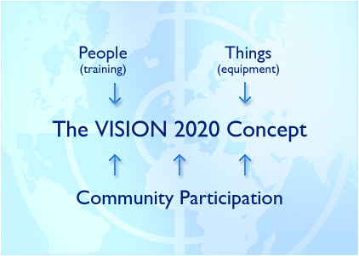

Despite worldwide recognition of its importance, there is lack of data on the global situation of human resource in eye care. To create a focus on HRD VISION 2020 has constituted a Human Resource Development Working Group (HRDWG).This working group has the following terms of references:

1. Use the existing data available from WHO, ICO, WHO Collaborating Centres, Ministries and other agencies to assess the availability of human resources in different cadres and their skill levels; training resources and the level of their utilization.
2. Whenever the Global Initiative document and other key VISION 2020-related publications are scheduled for revision, the HRWG will review and revise the HR section.
3. Develop and propose a strategic plan for achieving the Human Resource Development goals before the year 2020 (possibly by 2015). Take into account the many HR activities already underway within condition-focused initiatives and national plans. The plan will promote optimal use of today’s personnel, their continuing education, and the training of new personnel for deployment in regions of greatest need. Issues of team building, access, availability, and quality of resulting services will be the broader framework.
4. Establish criteria and framework for IAPB Resource Centers for VISION 2020 to promote and provide training for all levels of eye care personnel, with priority given to countries of greatest need.
5. Advocate the adoption of existing professional practice guidelines, as applicable to different levels of national health systems.
6. Facilitate creation of pilot projects that rapidly accelerate human resource development. For example: Facilitate development of Training Centres in different regions in collaboration with other organizations.
7. Encourage dissemination of basic minimum standards for Ophthalmology Residency training developed by ICO.
8. Respond to specific requests made by the WHO and/or the IAPB Board of Trustees that fall within the mandate of the HRWG.
9. Report at periodic intervals at the Meetings of WHO PBD and the IAPB Board of Trustees.
10. Access resources from VISION 2020 for fulfillment of Terms of Reference.

# 2. Objectives

**_______________________________________________________________________________**

Addressing the first term of reference HRDWG decided to undertake a global situation analysis on available human resource in Comprehensive eye care.

The situation analysis had the following objectives:

* To collect data globally and regionally on available human resources and their skill levels in eye care.
* To collect National disaggregated data on available human resources and training centers from countries identified as priority countries by the WHO.
* To identify the teaching and training institutions currently offering training of different cadres in the eye care team in the regions.
* To undertake gap analysis regionally keeping the VISION 2020 guidelines available.

# 3. Methods

**_______________________________________________________________________________**

In March 2006, a multidisciplinary team was formed at Pakistan Institute of Community Ophthalmology (PICO) to conduct the study. The team comprised of 2 community ophthalmologist, 2 epidemiologists, a data manger with two assistants, and a research medical officer. The methodology for data collection was based on multi-method approach. For collecting updated regional and country- based data special templates were designed in view of the objectives set for the situation analysis. From April 1-5, 2006, the team created data collection templates. The templates comprised of two Microsoft Word files (one for training institutions of doctors and one for allied eye care personnel) and two Microsoft Excel files(1 for doctors and 1 for allied health personnel). At the regional level the information aimed at for doctors working in eye care, was the total number of each of the specified categories in all the countries in a specific WHO-region. The same strategy was followed for optometrists and allied personnel in eye care. The templates are given in annex 1 and the variables are defined in annex 2.

The templates were reviewed and approved by the Vision 2020 Human Resource Development Working Group. Contact persons were identified in each of WHO’s 6 regions (Africa, Americas, EMR. Europe, SEA and WPR) and in the 20 priority countries (List of individuals, organizations and institutions contacted is given in Annex 3).

They were requested by email, courier, post and telephone calls to fill the templates or send reports addressing the templates with in one month and also provide reports which could act as reference for such information.

The information received was not as detailed and consistent as required to fill the templates therefore the categories defined in the templates had to be recategorized during analysis and summarized into just three categories of ophthalmologist, optometrist and allied personnel.

The data was analyzed in Microsoft Excel. For mapping the information the Global Information System (GIS), Arc view 3.1 was used.

For gap- analysis the vision 2020 targets[1] for 2010 were used. The targets are given in information box 1.

**Information box 1: Vision 2020 targets for human resource for 2010**

**Africa**

**Ophthalmologist 1 per 400,000 population**

**Ophthalmic medical assistants & ophthalmic nurses 1 per 200,000 population**

**Asia**

**Ophthalmologist 1 per 100,000 population**

**Ophthalmic medical assistants & ophthalmic nurses 1 per 100,000 population**

**For 2010**

Based on these targets a spectrum of categories was formulated to analyze the region- based data. These categories are summarized in table 1.

Table 1 Spectrum of Categories for categories for the availability of human resource

|  |  |  |  |  |  |  |
| --- | --- | --- | --- | --- | --- | --- |
| Region | | | Defining criteria | Category | Colour code for mapping | |
| Africa | | | | | | |
| Ophthalmologist | | | 1 per <400,000 population  1 per >=400,000-<500,000  1 per > =500,000  Data not available | A  B  C  D | Green  Blue  Red  Yellow | |
| Optometrist | | | 1 per <400,000 population  1 per >=400,000-<500,000  1 per > =500,000  Data not available | A  B  C  D | Green  Blue  Red  Yellow | |
| Allied personnel  (OMA & ophthalmic nurses) | | | 1 per <100,000 population  1 per >=100,000- <200,000  1 per >=200,000  Data not available | A  B  C  D | Green  Blue  Red  Yellow | |
| Americas | | | | | | |
| Ophthalmologist | 1 per < 50,000 population  1 per >=50,000 to <100,000  1 Americas  per >= 100,000  Data not available | | A  B  C  D | | Green  Blue  Red  Yellow | |
|  | Since no information could be gathered from this region regarding other specified cadres therefore further categorization was not done | | | |  | |
| Eastern Mediterranean | | | | | | |
| Ophthalmologist | 1 per <100,000 population  1 per >=100,000-300,000  1 per > =300,000  Data not available | | A  B  C  D | Green  Blue  Red  yellow | | |
| Optometrist | 1 per <100,000 population  1 per >=100,000-300,000  1 per > =300,000  Data not available | | A  B  C  D | Green  Blue  Red  Yellow | | |
| Allied personnel  (OMA & ophthalmic nurses) | 1 per <50,000 population  1 per >=50,000- <100,000  1 per >=100,000  Data not available | | A  B  C  D | Green  Blue  Red  Yellow | | |

|  |  |  |  |  |
| --- | --- | --- | --- | --- |
| Region | Defining criteria | Category | Colour code for mapping | |
| Europe | | | | |
| Ophthalmologist | 1 per < 50,000 population  1 per >=50,000 to <100,000  1 per >= 100,000  Data not available | A  B  C  D | Green  Blue  Red  yellow | |
|  | Since no information could be gathered from this region regarding other specified cadres therefore further categorization was not done | |  |
| South-East Asia | | | | |
| Ophthalmologist | 1 per <100,000 population  1 per >=100,000-300,000  1 per > =300,000  Data not available | A  B  C  D | Green  Blue  Red  yellow | |
| Optometrist | Data regarding this cadre was not available in this region hence no further analysis was done |  |  | |
| Allied personnel  (OMA & ophthalmic nurses) | 1 per <50,000 population  1 per >=50,000- <100,000  1 per >=100,000  Data not available | A  B  C  D | Green  Blue  Red  Yellow | |
| Western Pacific | | | | |
| Ophthalmologist | 1 per <100,000 population  1 per >=100,000-300,000  1 per > =300,000  Data not available | A  B  C  D | Green  Blue  Red  yellow | |
| Optometrist | 1 per <100,000 population  1 per >=100,000-300,000  1 per > =300,000  Data not available | A  B  C  D | Green  Blue  Red  Yellow | |
| Allied personnel  (OMA & ophthalmic nurses) | 1 per <50,000 population  1 per >=50,000- <100,000  1 per >=100,000  Data not available | A  B  C  D | Green  Blue  Red  Yellow | |

**Information box 2: Categories for analysis**

**A meets the Vision 2020 targets**

**B moderate HR needs**

**C greatest HR needs**

**D HR needs + greatest need for data on HR**

# 4. Results

**_________________________________________________________________________________**

This report addresses the global and aggregated data only, although the data collection for country –based data was also attempted but till the deadline for data collection no significant progress could be made on this front. Also the report is the first of a series and will be updated as and when more data becomes available. Data still continues to trickle in specially on Optometrists and Allied personnel. Those that read the report and who have more information and data are requested to kindly contact Dr. M. Babar Qureshi on [cbmpak@pes.comsats.net.pk](mailto:cbmpak@pes.comsats.net.pk) for inclusion in the subsequent reports.

Globally the paucity of data on human resource related to eye care was overwhelmingly highlighted as we found that the contact personnel had extreme difficulty in getting the data to start with and then to get a reference for such a data was even more difficult a task. Most of the information is based on available reports of WHO[2], Vision 2020 workshops[3], Vision 2020 reports, Vision 2020 websites[4] inputs from various eye care organizations[5], institutions and individuals.

# 

It was also seen that there was lack of definitions for different cadres of eye care personnel and it added to the difficulty in data collection.

The data is presented in the form of regional maps with detailed tables and relevant discussion under the categories of ophthalmologists, optometrists and allied eye care personnel. The information regarding training institutes is depicted in maps based on the availability of courses for ophthalmologists, community eye health and allied eye care personnel in various countries. The information is based on the VISION 2020 directory of training programmes (annexed with this report as annex). Any additional information collected during this study is given in annex 5.

## 4.1 Regional situation analysis of human resource for eye care

### 4.1.1 Africa

**__________________________________________________________________________________**

**4.1.1.1. Ophthalmologists**

The total number of ophthalmologists in the region is 2210, the data from only one country was not available. Africa as a whole with one ophthalmologist/ 326676.5 population, belongs to category A. Apparently it meets the target set by the vision 2020 initiative i.e one ophthalmologist/ 400,000 population. However keeping in view the widely dispersed population of Africa and the state of communication and transport system, even if the said target is met, accessibility would be a major hurdle in providing eye care coverage to the population.

Out of the 46 countries in the region only 14 (30.43%) countries manage to be in category A, while 27 (58.69%) remain in category “c”, the red alert category. The regional summary is given in table 2 and details of all the countries in the region are summarized in table 3. The human resource availability for the ophthalmologist in the African region is portrayed in the given map 1. The findings of gap analysis as regards the number of ophthalmologists in each country are summarized in table 4.

Table 2 Regional Summary of Africa regarding the availability of ophthalmologists

|  |  |  |
| --- | --- | --- |
| **Category** | **Defining criteria** | **Number of countries** |
| **A** | 1 per <400,000 population | **14** |
| **B** | 1 per >=400,000-<500,000 | **4** |
| **C** | 1 per > =500,000 | **27** |
| **D** | Data not available | **1** |

Table 3 Country-wise distribution of ophthalmologists in Africa

|  |  |  |  |  |  |
| --- | --- | --- | --- | --- | --- |
| **S.NO** | **Country** | **Population**  **(000)** | **Total No. of**  **Ophthalmol.** | **Population**  **Per**  **Ophthalmologist** | **Category** |
| 1 | Algeria | 32358 | 1000 | 32358.0 | **A** |
| 2 | Angola | 15490 | 10 | 1549000.0 | **C** |
| 3 | Benin | 8177 | 26 | 314500.0 | **A** |
| 4 | Botswana | 1769 | 9 | 196555.6 | **A** |
| 5 | Burkina Faso | 12822 | 21 | 610571.4 | **C** |
| 6 | Burundi | 7282 | 7 | 1040285.7 | **C** |
| 7 | Cameroon | 16038 | 51 | 314470.6 | **A** |
| 8 | Cape Verde | 495 | 6 | 82500.0 | **A** |
| 9 | Central African Republic | 3986 | 3 | 1328666.7 | **C** |
| 10 | Chad | 9448 | 3 | 3149333.3 | **C** |
| 11 | Comoros | 777 | 2 | 388500.0 | **A** |
| 12 | Congo | 3883 | 3 | 1294333.3 | **C** |
| 13 | Cote d’Ivoire | 17872 | 48 | 372333.3 | **A** |
| 14 | Democratic Republic of Congo | 55853 | 44 | 1269386.4 | **C** |
| 15 | Equatorial Guinea | 492 | 3 | 164000.0 | **A** |
| 16 | Eritrea | 4232 | 6 | 705333.3 | **C** |
| 17 | Ethiopia | 75600 | 76 | 994736.8 | **C** |
| 18 | Gabon | 1362 | 9 | 151333.3 | **A** |
| 19 | Gambia | 1478 | 2 | 739000.0 | **C** |
| 20 | Ghana | 21664 | 48 | 451333.3 | **B** |
| 21 | Guinea | 9202 | 7 | 1314571.4 | **C** |
| 22 | Guinea-Bissau | 1540 | 1 | 1540000.0 | **C** |

|  |  |  |  |  |  |
| --- | --- | --- | --- | --- | --- |
| **S.NO** | **Country** | **Population**  **(000)** | **Total No. of**  **ophthalmologists** | **Population**  **Per**  **Ophthalmologist** | **Category** |
| 23 | Kenya | 33467 | 60 | 557783.3 | **C** |
| 24 | Lesotho | 1798 | 2 | 899000.0 | **C** |
| 25 | Liberia | 3241 | 6 | 540166.7 | **C** |
| 26 | Madagascar | 18113 | 21 | 862523.8 | **C** |
| 27 | Malawi | 12608 | 6 | 2101333.3 | **C** |
| 28 | Mali | 13124 | 26 | 504769.2 | **C** |
| 29 | Mauritania | 2980 | 6 | 496666.7 | **B** |
| 30 | Mauritius | 1233 | 9 | 137000.0 | **A** |
| 31 | Mozambique | 19424 | 14 | 1387428.6 | **C** |
| 32 | Namibia | 2009 | 5 | 401800.0 | **B** |
| 33 | Niger | 13499 | 10 | 1349900.0 | **C** |
| 34 | Nigeria | 128709 | 255 | 504741.2 | **C** |
| 35 | Rwanda | 8882 | 5 | 1776400.0 | **C** |
| 36 | Sao Tome and Principe | 153 | 1 | 153000.0 | **A** |
| 37 | Senegal | 11386 | 25 | 455440.0 | **B** |
| 38 | Seychelles | 80 | 3 | 26666.7 | **A** |
| 39 | Sierra Leone | 5336 | 3 | 1778666.7 | **C** |
| 40 | South Africa | 47208 | 242 | 195074.4 | **A** |
| 41 | Swaziland | 1034 | - | - | **D** |
| 42 | Togo | 5988 | 17 | 352235.3 | **A** |
| 43 | Uganda | 27821 | 39 | 713359.0 | **C** |
| 44 | United Republic of Tanzania | 37627 | 31 | 1213774.2 | **C** |
| 45 | Zambia | 11479 | 14 | 819928.6 | **C** |
| 46 | Zimbabwe | 12936 | 25 | 517440.0 | **C** |
|  | **Regional aggregate** | **721955** | **2210** | **326676.5** | **A** |



Map 1 Country - wise distribution of ophthalmologists in Africa

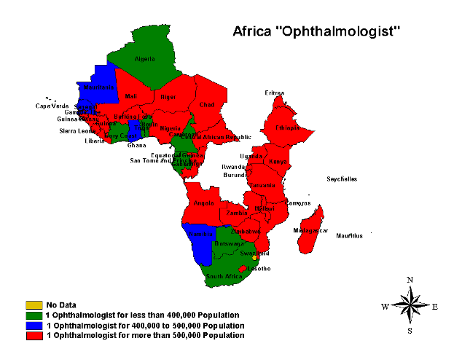empty

Proportion of countries in each category

**No Data**

**1 Ophthalmologist for less than 400,000 Population**

**1 Ophthalmologist for 400,000 to 500,000 Population**

**1 Ophthalmologist for more than 500,000 Population**

Table 4 Gap analysis in relation to the number of Ophthalmologists in Africa

|  |  |  |  |  |  |
| --- | --- | --- | --- | --- | --- |
|  | **Country** | **Total No. of**  **ophthalmologists** | **Current ophthalmologist: Population**  **ratio** | **Category** | **Number of ophthalmologists required to maintain the target ratio of 1: 400,000** |
| 1 | Algeria | 1000 | 32358.0 | **A** | - |
| 2 | Angola | 10 | 1549000.0 | **C** | 39 |
| 3 | Benin | 26 | 314500.0 | **A** | - |
| 4 | Botswana | 9 | 196555.6 | **A** | - |
| 5 | Burkina Faso | 21 | 610571.4 | **C** | 33 |
| 6 | Burundi | 7 | 1040285.7 | **C** | 19 |
| 7 | Cameroon | 51 | 314470.6 | **A** | - |
| 8 | Cape Verde | 6 | 82500.0 | **A** | - |
| 9 | Central African Republic | 3 | 1328666.7 | **C** | 10 |
| 10 | Chad | 3 | 3149333.3 | **C** | 24 |
| 11 | Comoros | 2 | 388500.0 | **A** | - |
| 12 | Congo | 3 | 1294333.3 | **C** | 10 |
| 13 | Cote d’Ivoire | 48 | 372333.3 | **A** | - |
| 14 | Democratic Republic of Congo | 44 | 1269386.4 | **C** | 140 |
| 15 | Equatorial Guinea | 3 | 164000.0 | **A** | - |
| 16 | Eritrea | 6 | 705333.3 | **C** | 11 |
| 17 | Ethiopia | 76 | 994736.8 | **C** | 190 |
| 18 | Gabon | 9 | 151333.3 | **A** | - |
| 19 | Gambia | 2 | 739000.0 | **C** | 4 |
| 20 | Ghana | 48 | 451333.3 | **B** | 55 |
| 21 | Guinea | 7 | 1314571.4 | **C** | 24 |
| 22 | Guinea-Bissau | 1 | 1540000.0 | **C** | 4 |
|  | **Country** | **Total No. of**  **ophthalmologists** | **Current ophthalmologist: Population**  **ratio** | **Category** | **Number of ophthalmologists required to maintain the target ratio of 1: 400,000** |
| 23 | Kenya | 60 | 557783.3 | **C** | 84 |
| 24 | Lesotho | 2 | 899000.0 | **C** | 5 |
| 25 | Liberia | 6 | 540166.7 | **C** | 9 |
| 26 | Madagascar | 21 | 862523.8 | **C** | 46 |
| 27 | Malawi | 6 | 2101333.3 | **C** | 32 |
| 28 | Mali | 26 | 504769.2 | **C** | 33 |
| 29 | Mauritania | 6 | 496666.7 | **B** | 8 |
| 30 | Mauritius | 9 | 137000.0 | **A** | - |
| 31 | Mozambique | 14 | 1387428.6 | **C** | 49 |
| 32 | Namibia | 5 | 401800.0 | **B** | 6 |
| 33 | Niger | 10 | 1349900.0 | **C** | 34 |
| 34 | Nigeria | 255 | 504741.2 | **C** | 322 |
| 35 | Rwanda | 5 | 1776400.0 | **C** | 23 |
| 36 | Sao Tome and Principe | 1 | 153000.0 | **A** | - |
| 37 | Senegal | 25 | 455440.0 | **B** | 29 |
| 38 | Seychelles | 3 | 26666.7 | **A** | - |
| 39 | Sierra Leone | 3 | 1778666.7 | **C** | 14 |
| 40 | South Africa | 242 | 195074.4 | **A** | - |
| 41 | Swaziland | - |  | **D** | 3 |
| 42 | Togo | 17 | 352235.3 | **A** | - |
| 43 | Uganda | 39 | 713359.0 | **C** | 70 |
| 44 | United Republic of Tanzania | 31 | 1213774.2 | **C** | 95 |
| 45 | Zambia | 14 | 819928.6 | **C** | 29 |
| 46 | Zimbabwe | 25 | 517440.0 | **C** | 33 |
|  | **Regional aggregate** | **2210** | **326676.5** | **A** | - |

**4.1.1.2. Optometrists**

The total number of optometrists in Africa was found to be 1690 with an overall population ratio of one optometrist per 427192.3 people, placing the region in category B. the data concerning number of optometrists in each country was not available for almost half of the countries in the region. Eighteen (39.13%) of the countries belonged to category C while only 3(6.52%) of the countries were found to be in the A category. Regional summary is provided in table 5 while details of all the countries in the region are summarized in table 6. The human resource availability in terms of optometrists in the African region is mapped in the map 2. The findings of gap analysis as regards the number of ophthalmologists in each country are summarized in table 7.

Table 5 Regional Summary of Africa regarding the availability of optometrists

|  |  |  |
| --- | --- | --- |
| **Category** | **Defining criteria** | **Number of countries** |
| **A** | 1 per <400,000 population | **3** |
| **B** | 1 per >=400,000-<500,000 | **0** |
| **C** | 1 per > =500,000 | **18** |
| **D** | Data not available | **25** |

Table 6 Country-wise distribution of optometrists in Africa

|  |  |  |  |  |  |
| --- | --- | --- | --- | --- | --- |
|  | **Country** | **Population**  **(000)** | **Total No of**  **Optometrists** | **Population per optometrist** | **Category** |
| 1 | Algeria | 32358 | - | - | D |
| 2 | Angola | 15490 | 15 | 1032666.7 | C |
| 3 | Benin | 8177 | 2 | 4088500.0 | C |
| 4 | Botswana | 1769 | - | - | D |
| 5 | Burkina Faso | 12822 | - | - | D |
| 6 | Burundi | 7282 | - | - | D |
| 7 | Cameroon | 16038 | - | - | D |
| 8 | Cape Verde | 495 | - | - | D |
| 9 | Central African Republic | 3986 | - | - | D |
| 10 | Chad | 9448 | - | - | D |
| 11 | Comoros | 777 | 1 | 777000.0 | C |
| 12 | Congo | 3883 | - | - | D |
| 13 | Cote d’Ivoire | 17872 | - | - | D |
| 14 | Democratic Republic of Congo | 55853 | 20 | 2792650.0 | C |
| 15 | Equatorial Guinea | 492 | 2 | 246000.0 | A |
| 16 | Eritrea | 4232 | 1 | 4232000.0 | C |
| 17 | Ethiopia | 75600 | 8 | 9450000.0 | C |
| 18 | Gabon | 1362 | - | - | D |
| 19 | Gambia | 1478 | 1 | 1478000.0 | C |
| 20 | Ghana | 21664 | 40 | 541600.0 | C |
| 21 | Guinea | 9202 | 2 | 4601000.0 | C |
| 22 | Guinea-Bissau | 1540 | - | - | D |
| 23 | Kenya | 33467 | 5 | 6693400.0 | C |
| 24 | Lesotho | 1798 | - | - | D |
| 25 | Liberia | 3241 | 2 | 1620500.0 | C |
|  | **Country** | **Population**  **(000)** | **Total No of**  **Optometrists** | **Population per optometrist** | **Category** |
| 26 | Madagascar | 18113 | - | - | D |
| 27 | Malawi | 12608 | 2 | 6304000.0 | C |
| 28 | Mali | 13124 | 1 | 13124000.0 | C |
| 29 | Mauritania | 2980 | - | - | D |
| 30 | Mauritius | 1233 | - | - | D |
| 31 | Mozambique | 19424 | 1 | 19424000.0 | C |
| 32 | Namibia | 2009 | - | - | D |
| 33 | Niger | 13499 | - | - | D |
| 34 | Nigeria | 128709 | 1560 | 82505.8 | A |
| 35 | Rwanda | 8882 | - | - | D |
| 36 | Sao Tome and Principe | 153 | - | - | D |
| 37 | Senegal | 11386 | - | - | D |
| 38 | Seychelles | 80 | 2 | 40000.0 | A |
| 39 | Sierra Leone | 5336 | - | - | D |
| 40 | South Africa | 47208 | - | - | D |
| 41 | Swaziland | 1034 | - | - | D |
| 42 | Togo | 5988 | 1 | 5988000.0 | C |
| 43 | Uganda | 27821 | 14 | 1987214.3 | C |
| 44 | United Republic of Tanzania | 37627 | - | - | D |
| 45 | Zambia | 11479 | 2 | 5739500.0 | C |
| 46 | Zimbabwe | 12936 | 8 | 1617000.0 | C |
|  | **Regional aggregate** | **721955** | **1690** | **427192.3** | **B** |

Map 2 Country –wise distribution of optometrists in Africa

empty

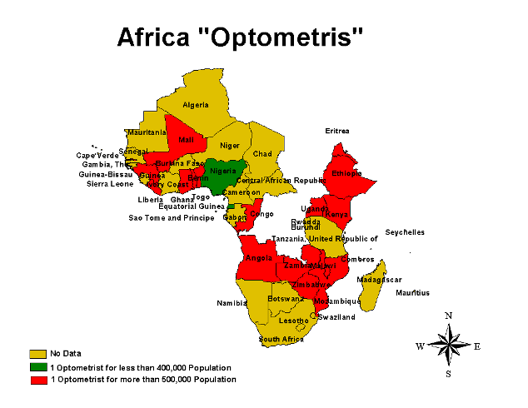

Proportion of countries in each category

**No Data**

**1 Optometrist for less than 400,000 Population**

**1 Optometrist for more than 500,000 Population**

Table 7 Gap analysis in relation to the number of Optometrists in Africa

|  |  |  |  |  |  |
| --- | --- | --- | --- | --- | --- |
|  | **Country** | **Total No. of**  **Optometrists** | **Current Optometrist :Population**  **ratio** | **Category** | **Number of optometrists required to maintain the target ratio of 1: 400,000** |
| 1 | Algeria | - | - | D | 81 |
| 2 | Angola | 15 | 1032666.7 | C | 39 |
| 3 | Benin | 2 | 4088500.0 | C | 21 |
| 4 | Botswana | - | - | D | 5 |
| 5 | Burkina Faso | - | - | D | 33 |
| 6 | Burundi | - | - | D | 19 |
| 7 | Cameroon | - | - | D | 41 |
| 8 | Cape Verde | - | - | D | 2 |
| 9 | Central African Republic | - | - | D | 10 |
| 10 | Chad | - | - | D | 24 |
| 11 | Comoros | 1 | 777000.0 | C | 2 |
| 12 | Congo | - | - | D | 10 |
| 13 | Cote d’Ivoire | - | - | D | 45 |
| 14 | Democratic Republic of Congo | 20 | 2792650.0 | C | 140 |
| 15 | Equatorial Guinea | 2 | 246000.0 | A | - |
| 16 | Eritrea | 1 | 4232000.0 | C | 11 |
| 17 | Ethiopia | 8 | 9450000.0 | C | 189 |
| 18 | Gabon | - | - | D | 4 |
| 19 | Gambia | 1 | 1478000.0 | C | 4 |
| 20 | Ghana | 40 | 541600.0 | C | 55 |
| 21 | Guinea | 2 | 4601000.0 | C | 24 |
| 22 | Guinea-Bissau | - | - | D | 4 |
| 23 | Kenya | 5 | 6693400.0 | C | 84 |
|  | **Country** | **Total No. of**  **Optometrists** | **Current Optometrist :Population**  **ratio** | **Category** | **Number of optometrists required to maintain the target ratio of 1: 400,000** |
| 24 | Lesotho | - | - | D | 5 |
| 25 | Liberia | 2 | 1620500.0 | C | 9 |
| 26 | Madagascar | - | - | D | 46 |
| 27 | Malawi | 2 | 6304000.0 | C | 32 |
| 28 | Mali | 1 | 13124000.0 | C | 33 |
| 29 | Mauritania | - | - | D | 8 |
| 30 | Mauritius | - | - | D | 4 |
| 31 | Mozambique | 1 | 19424000.0 | C | 49 |
| 32 | Namibia | - | - | D | 6 |
| 33 | Niger | - | - | D | 34 |
| 34 | Nigeria | 1560 | 82505.8 | A |  |
| 35 | Rwanda | - | - | D | 23 |
| 36 | Sao Tome and Principe | - | - | D | 1 |
| 37 | Senegal | - | - | D | 29 |
| 38 | Seychelles | 2 | 40000.0 | A |  |
| 39 | Sierra Leone | - | - | D | 14 |
| 40 | South Africa | - | - | D | 119 |
| 41 | Swaziland | - | - | D | 3 |
| 42 | Togo | 1 | 5988000.0 | C | 15 |
| 43 | Uganda | 14 | 1987214.3 | C | 70 |
| 44 | United Republic of Tanzania | - | - | D | 95 |
| 45 | Zambia | 2 | 5739500.0 | C | 29 |
| 46 | Zimbabwe | 8 | 1617000.0 | C | 33 |
|  | **Regional aggregate** | **1690** | **427192.3** | **B** | **1805** |

**4.1.1.3. Ophthalmic allied personnel**

The total number of ophthalmic allied personnel in Africa was found to be 7253 with a population ratio of one allied person per 99538.8 people. By virtue of this ratio Africa is placed in the A category but keeping in view the needs of the population and the accessibility barriers this number can not be considered as being sufficient. Seventeen (36.95%) of the countries belonged to the red alert category “c” while 15 (32.60%) countries were found to be in the A category. The data was not available for 6 countries.

Regional summary of the situation analysis of ophthalmic allied personnel in Africa is provided in table 8 while details of all the countries in the region are summarized in table 9. The human resource availability in terms of ophthalmic allied personnel in the African region is mapped in the map 3. The findings of gap analysis as regards the number of ophthalmic allied personnel in each country are summarized in table 10.

Table 8 Regional Summary of the number of ophthalmic allied personnel in Africa

|  |  |  |
| --- | --- | --- |
| **Category** | **Defining criteria** | **Number of countries** |
| **A** | 1 per <100,000 population | **15** |
| **B** | 1 per >=100,000- <200,000 | **8** |
| **C** | 1 per >=200,000 | **17** |
| **D** | Data not available | **6** |

Table 9 Country-wise distribution of ophthalmic allied personnel in Africa

|  |  |  |  |  |  |
| --- | --- | --- | --- | --- | --- |
|  | **Country** | **Population**  **(000)** | **Total No of**  **Allied Personnel’s** | **Population per Allied Personnel** | **Category** |
| 1 | Algeria | 32358 | - | - | D |
| 2 | Angola | 15490 | 41 | 377804.9 | C |
| 3 | Benin | 8177 | 34 | 240500.0 | C |
| 4 | Botswana | 1769 | 104 | 17009.6 | A |
| 5 | Burkina Faso | 12822 | 104 | 123288.5 | B |
| 6 | Burundi | 7282 | 9 | 809111.1 | C |
| 7 | Cameroon | 16038 | 10 | 1603800.0 | C |
| 8 | Cape Verde | 495 | 9 | 55000.0 | A |
| 9 | Central African Republic | 3986 | 14 | 284714.3 | C |
| 10 | Chad | 9448 | 64 | 147625.0 | B |
| 11 | Comoros | 777 | 13 | 59769.2 | A |
| 12 | Congo | 3883 | 5 | 776600.0 | C |
| 13 | Cote d’Ivoire | 17872 | 102 | 175215.7 | B |
| 14 | Democratic Republic of Congo | 55853 | 617 | 90523.5 | A |
| 15 | Equatorial Guinea | 492 | 3 | 164000.0 | B |
| 16 | Eritrea | 4232 | 61 | 69377.0 | A |
| 17 | Ethiopia | 75600 | 183 | 413114.8 | C |
| 18 | Gabon | 1362 | - | - | D |
| 19 | Gambia | 1478 | 15 | 98533.3 | A |
| 20 | Ghana | 21664 | 1882 | 11511.2 | A |
| 21 | Guinea | 9202 | 33 | 278848.5 | C |
| 22 | Guinea-Bissau | 1540 | 19 | 81052.6 | A |
| 23 | Kenya | 33467 | 161 | 207869.6 | C |
| 24 | Lesotho | 1798 | - | - | D |
| 25 | Liberia | 3241 | 12 | 270083.3 | C |
|  | **Country** | **Population**  **(000)** | **Total No of**  **Allied Personnel’s** | **Population per Allied Personnel** | **Category** |
| 26 | Madagascar | 18113 | 67 | 270343.3 | C |
| 27 | Malawi | 12608 | 434 | 29050.7 | A |
| 28 | Mali | 13124 | 101 | 129940.6 | B |
| 29 | Mauritania | 2980 | - | - | D |
| 30 | Mauritius | 1233 | 92 | 13402.2 | A |
| 31 | Mozambique | 19424 | 67 | 289910.4 | C |
| 32 | Namibia | 2009 | 56 | 35875.0 | A |
| 33 | Niger | 13499 | 36 | 374972.2 | C |
| 34 | Nigeria | 128709 | 2070 | 62178.3 | A |
| 35 | Rwanda | 8882 | 5 | 1776400.0 | C |
| 36 | Sao Tome and Principe | 153 | 3 | 51000.0 | A |
| 37 | Senegal | 11386 | 105 | 108438.1 | B |
| 38 | Seychelles | 80 | 15 | 5333.3 | A |
| 39 | Sierra Leone | 5336 | 45 | 118577.8 | B |
| 40 | South Africa | 47208 | - | - | D |
| 41 | Swaziland | 1034 | - | - | D |
| 42 | Togo | 5988 | 38 | 157578.9 | B |
| 43 | Uganda | 27821 | 344 | 80875.0 | A |
| 44 | United Republic of Tanzania | 37627 | 175 | 215011.4 | C |
| 45 | Zambia | 11479 | 54 | 212574.1 | C |
| 46 | Zimbabwe | 12936 | 51 | 253647.1 | C |
|  | Regional aggregate | 721955 | 7253 | 99538.8 | A |

Map 3 Country - wise distribution of Ophthalmic allied personnel in Africa

empty

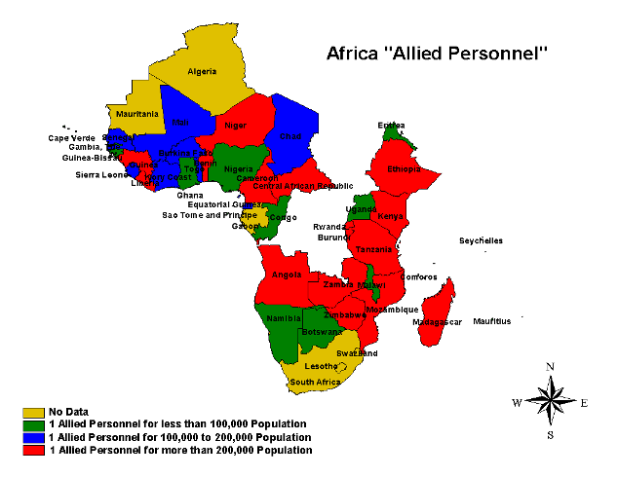

Proportion of countries in each category

**No Data**

**1 Allied Personnel for less than 100,000 Population**

**1 Allied Personnel for 100,000 to 200,000 Population**

**1 Allied Personnel for more than 200,000 Population**

Table 10 Gap analysis in relation to the number of Allied Personnel in Africa

|  |  |  |  |  |  |
| --- | --- | --- | --- | --- | --- |
|  | **Country** | **Total No. of**  **Ophthalmic allied personnel** | **Current allied personnel: Population**  **ratio** | **Category** | **Number of allied personnel required to maintain the target ratio of 1: 100,000** |
| 1 | Algeria | - | - | D | 324 |
| 2 | Angola | 41 | 377804.9 | C | 155 |
| 3 | Benin | 34 | 240500.0 | C | 82 |
| 4 | Botswana | 104 | 17009.6 | A |  |
| 5 | Burkina Faso | 104 | 123288.5 | B | 129 |
| 6 | Burundi | 9 | 809111.1 | C | 73 |
| 7 | Cameroon | 10 | 1603800.0 | C | 161 |
| 8 | Cape Verde | 9 | 55000.0 | A |  |
| 9 | Central African Republic | 14 | 284714.3 | C | 40 |
| 10 | Chad | 64 | 147625.0 | B | 95 |
| 11 | Comoros | 13 | 59769.2 | A |  |
| 12 | Congo | 5 | 776600.0 | C | 39 |
| 13 | Cote d’Ivoire | 102 | 175215.7 | B | 179 |
| 14 | Democratic Republic of Congo | 617 | 90523.5 | A | - |
| 15 | Equatorial Guinea | 3 | 164000.0 | B | 5 |
| 16 | Eritrea | 61 | 69377.0 | A | - |
| 17 | Ethiopia | 183 | 413114.8 | C | 756 |
| 18 | Gabon | - | - | D | 14 |
| 19 | Gambia | 15 | 98533.3 | A |  |
| 20 | Ghana | 1882 | 11511.2 | A | - |
| 21 | Guinea | 33 | 278848.5 | C | 93 |
| 22 | Guinea-Bissau | 19 | 81052.6 | A | - |
|  | **Country** | **Total No. of**  **Ophthalmic allied personnel** | **Current allied personnel: Population**  **ratio** | **Category** | **Number of allied personnel required to maintain the target ratio of 1: 100,000** |
| 23 | Kenya | 161 | 207869.6 | C | 335 |
| 24 | Lesotho | - | - | D | 18 |
| 25 | Liberia | 12 | 270083.3 | C | 33 |
| 26 | Madagascar | 67 | 270343.3 | C | 182 |
| 27 | Malawi | 434 | 29050.7 | A |  |
| 28 | Mali | 101 | 129940.6 | B | 132 |
| 29 | Mauritania | - | - | D | 30 |
| 30 | Mauritius | 92 | 13402.2 | A | - |
| 31 | Mozambique | 67 | 289910.4 | C | 195 |
| 32 | Namibia | 56 | 35875.0 | A | - |
| 33 | Niger | 36 | 374972.2 | C | 135 |
| 34 | Nigeria | 2070 | 62178.3 | A | - |
| 35 | Rwanda | 5 | 1776400.0 | C | 89 |
| 36 | Sao Tome and Principe | 3 | 51000.0 | A | - |
| 37 | Senegal | 105 | 108438.1 | B | 114 |
| 38 | Seychelles | 15 | 5333.3 | A | - |
| 39 | Sierra Leone | 45 | 118577.8 | B | 54 |
| 40 | South Africa | - | - | D | 473 |
| 41 | Swaziland | - | - | D | 11 |
| 42 | Togo | 38 | 157578.9 | B | 60 |
| 43 | Uganda | 344 | 80875.0 | A | - |
| 44 | United Republic of Tanzania | 175 | 215011.4 | C | 377 |
| 45 | Zambia | 54 | 212574.1 | C | 115 |
| 46 | Zimbabwe | 51 | 253647.1 | C | 130 |
|  | **Regional aggregate** | **7253** | **99538.8** | **A** | - |

### 4.1.2. Americas

**_______________________________________________________________________**

**4.1.2.1. Ophthalmologist**

The total number of ophthalmologists in the region is 45,700 with a population ration of one ophthalmologist per 19,161 people. The overall category for the region was “A”. Twenty-one (60%) countries of the region were from the category A, while 11.42% belonged to category C.

As regards the presence of ophthalmologist, the regional summary for Americas is given in table 11 and details of all the countries in the region are summarized in table 12. Human resource availability for the ophthalmologist in the region is presented in map 4. The findings of gap analysis as regards the number of ophthalmologists in each country are summarized in table 13.

Table 11 Regional Summary of Americas regarding the number of ophthalmologists

|  |  |  |
| --- | --- | --- |
| **Category** | **Defining criteria** | **Number of countries** |
| **A** | 1 per < 50,000 population | **21** |
| **B** | 1 per >=50,000 to <100,000 | **9** |
| **C** | 1 per >= 100,000 | **4** |
| **D** | Data not available | **1** |

Table 12 Country-wise distribution of ophthalmologists in Americas

|  |  |  |  |  |  |
| --- | --- | --- | --- | --- | --- |
|  | **Country** | **Population**  **(000)** | **Total No. of**  **ophthalmologists** | **Population**  **Per**  **Ophthalmologist** | **Category** |
| 1 | Antigua and Barbuda | 81 | 10 | 8100.0 | A |
| 2 | Argentina | 38372 | 3460 | 11090.2 | A |
| 3 | Bahamas | 319 | 6 | 53166.7 | B |
| 4 | Barbados | 269 | 10 | 26900.0 | A |
| 5 | Belize | 264 | 4 | 66000.0 | B |
| 6 | Bolivia | 9009 | 130 | 69300.0 | B |
| 7 | Brazil | 183913 | 11,350 | 16203.8 | A |
| 8 | Canada | 31958 | 800 | 39947.5 | A |
| 9 | Chile | 16124 | 790 | 20410.1 | A |
| 10 | Colombia | 44915 | 1260 | 35646.8 | A |
| 11 | Costa Rica | 4253 | 100 | 42530.0 | A |
| 12 | Cuba | 11245 | 620 | 18137.1 | A |
| 13 | Dominica | 79 | 1 | 79000.0 | B |
| 14 | Dominican Republic | 8768 | 220 | 39854.5 | A |
| 15 | Ecuador | 13040 | 340 | 38352.9 | A |
| 16 | El Salvador | 6762 | 136 | 49720.6 | A |
| 17 | Grenada | 102 | 1 | 102000.0 | C |
| 18 | Guatemala | 12295 | 151 | 81423.8 | B |
| 19 | Guyana | 750 | 5 | 150000.0 | C |
| 20 | Haiti | 8407 | 55 | 152854.5 | C |
| 21 | Honduras | 7048 | 60 | 117466.7 | C |
| 22 | Jamaica | 2639 | 43 | 61372.1 | B |
| 23 | Mexico | 105699 | 3400 | 31087.9 | A |
| 24 | Nicaragua | 5376 | 54 | 99555.6 | B |
| 25 | Panama | 3175 | 120 | 26458.3 | A |
| 26 | Paraguay | 6017 | 150 | 40113.3 | A |
| 27 | Peru | 27562 | 850 | 32425.9 | A |
| 28 | Saint Kitts and Nevis | 42 | 1 | 42000.0 | A |

|  |  |  |  |  |  |
| --- | --- | --- | --- | --- | --- |
|  | **Country** | **Population**  **(000)** | **Total No. of**  **ophthalmologists** | **Population**  **Per**  **Ophthalmologist** | **Category** |
| 29 | Saint Lucia | 159 | 2 | 79500.0 | B |
| 30 | Saint Vincent and the Grenadines | 118 | 2 | 59000.0 | B |
| 31 | Suriname | 446 | 10 | 44600.0 | A |
| 32 | Trinidad and Tobago | 1301 | - | - | D |
| 33 | USA | 295410 | 20,439 | 14453.3 | A |
| 34 | Uruguay | 3439 | 220 | 15631.8 | A |
| 35 | Venezuela | 26282 | 900 | 29202.2 | A |
|  | **Regional aggregate** | **875638** | **45700** | **19160.6** | **A** |

Map 4 Country- wise distribution of ophthalmologists in Americas

empty

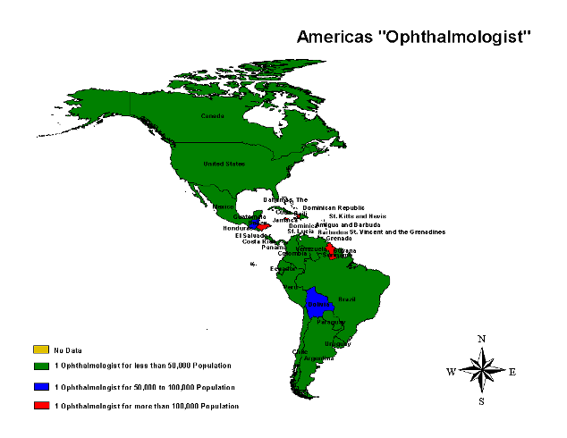

Proportion of countries in each category

**No Data**

**1 Ophthalmologist for less than 50,000 Population**

**1 Ophthalmologist for 50,000 to 100,000 Population**

**1 Ophthalmologist for more than 100,000 Population**

Table 13 Gap analysis in relation to the number of Ophthalmologists in Americas

|  |  |  |  |  |  |
| --- | --- | --- | --- | --- | --- |
|  | **Country** | **Total No. of**  **ophthalmologists** | **Current ophthalmologist: Population**  **ratio** | **Category** | **Number of ophthalmologists required to maintain the target ratio of 1: 50,000** |
| 1 | Antigua and Barbuda | 10 | 8100.0 | A | - |
| 2 | Argentina | 3460 | 11090.2 | A | - |
| 3 | Bahamas | 6 | 53166.7 | B | 7 |
| 4 | Barbados | 10 | 26900.0 | A | - |
| 5 | Belize | 4 | 66000.0 | B | 6 |
| 6 | Bolivia | 130 | 69300.0 | B | 181 |
| 7 | Brazil | 11,350 | 16203.8 | A | - |
| 8 | Canada | 800 | 39947.5 | A | - |
| 9 | Chile | 790 | 20410.1 | A | - |
| 10 | Colombia | 1260 | 35646.8 | A | - |
| 11 | Costa Rica | 100 | 42530.0 | A | - |
| 12 | Cuba | 620 | 18137.1 | A | - |
| 13 | Dominica | 1 | 79000.0 | B | 2 |
| 14 | Dominican Republic | 220 | 39854.5 | A | - |
| 15 | Ecuador | 340 | 38352.9 | A | - |
| 16 | El Salvador | 136 | 49720.6 | A | - |
| 17 | Grenada | 1 | 102000.0 | C | 3 |
| 18 | Guatemala | 151 | 81423.8 | B | 246 |
| 19 | Guyana | 5 | 150000.0 | C | 15 |
| 20 | Haiti | 55 | 152854.5 | C | 169 |
| 21 | Honduras | 60 | 117466.7 | C | 141 |
| 22 | Jamaica | 43 | 61372.1 | B | 53 |
| 23 | Mexico | 3400 | 31087.9 | A | - |
| 24 | Nicaragua | 54 | 99555.6 | B | 108 |
| 25 | Panama | 120 | 26458.3 | A | - |
| 26 | Paraguay | 150 | 40113.3 | A | - |

|  |  |  |  |  |  |
| --- | --- | --- | --- | --- | --- |
|  | **Country** | **Total No. of**  **ophthalmologists** | **Current Ophthalmologist: Population**  **ratio** | **Category** | **Number of ophthalmologists required to maintain the target ratio of 1: 50,000** |
| 27 | Peru | 850 | 32425.9 | A | - |
| 28 | Saint Kitts and Nevis | 1 | 42000.0 | A | - |
| 29 | Saint Lucia | 2 | 79500.0 | B | 4 |
| 30 | Saint Vincent and the Grenadines | 2 | 59000.0 | B | 3 |
| 31 | Suriname | 10 | 44600.0 | A | - |
| 32 | Trinidad and Tobago | - | - | D | 27 |
| 33 | USA | 20,439 | 14453.3 | A | - |
| 34 | Uruguay | 220 | 15631.8 | A | - |
| 35 | Venezuela | 900 | 29202.2 | A | - |
| **4.1.2.2 Other cadres**  Besides ophthalmologists no concrete information could be accessed regarding other cadres of eye care personnel including optometrists. | **Regional aggregate** | 45700 | 1960.6 | A | - |

### 4.1.3. Eastern Mediterranean

**__________________________________________________________________________________**

**4.1.3.1 Ophthalmologists**

The total number of ophthalmologists in EMR is 12,298 bringing the population ratio to one ophthalmologist per 42834 population. The data concerning number of ophthalmologists in each country was available for all the contries of the region. EMR as a whole was found to be in category A. However the information needs to be carefully interpreted as many of the EMR countries are going through a transitional phase of socioeconomic development. This has lead to the emergence of a diverse situation as regards health generally and eye health specifically with impending problem of control and prevention of communicable diseases which have decreased in magnitude over the years but have not been eliminated and the growing incidence of chronic non-communicable diseases. This poses a dual problem in eye care provision as all public health interventions have to be designed in such a manner to address the two issues simultaneously. Therefore although most of the countries in the region meet the 1ophthalmologist : 100,000 population criteria but this is a modest estimate and may not be sufficient to meet emerging regional needs of the population.

Regional summary for the distribution of ophthalmologists in EMR is provided in table 14 while details of all the countries in the region are summarized in table 15. The human resource availability in terms of ophthalmologists in the EMR is presented in map 5. The findings of gap analysis as regards the number of ophthalmologists in each country are summarized in table 16.

Table 14 Regional Summary of EMR regarding the availability of ophthalmologists

|  |  |  |
| --- | --- | --- |
| Category | **Defining criteria** | **Number of countries** |
| **A** | 1 per <100,000 population | **15** |
| **B** | 1 per >=100,000-300,000 | **3** |
| **C** | 1 per > =300,000 | **3** |
| **D** | Data not available | **0** |

Table 15 Country-wise distribution of ophthalmologists in EMR

|  |  |  |  |  |  |
| --- | --- | --- | --- | --- | --- |
|  | **Country** | **Population**  **(000)** | **Total No. of**  **ophthalmologists** | **Population**  **Per**  **Ophthalmologist** | **Category** |
| 1 | Afghanistan | 28574 | 86 | 332255.8 | C |
| 2 | Bahrain | 716 | 36 | 19888.9 | A |
| 3 | Djibouti | 779 | 2 | 389500.0 | C |
| 4 | Egypt | 72642 | 5240 | 13863.0 | A |
| 5 | Iran (Islamic Republic of) | 68803 | 1230 | 55937.4 | A |
| 6 | Iraq | 28057 | 140 | 200407.1 | B |
| 7 | Jordan | 5561 | 231 | 24073.6 | A |
| 8 | Kuwait | 2606 | 72 | 36194.4 | A |
| 9 | Lebanon | 3540 | 219 | 16164.4 | A |
| 10 | Libyan Arab Jamahiriya | 5740 | 170 | 33764.7 | A |
| 11 | Morocco | 31020 | 1030 | 30116.5 | A |
| 12 | Oman | 2534 | 104 | 24365.4 | A |
| 13 | Pakistan | 154794 | 1860 | 83222.6 | A |
| 14 | Qatar | 777 | 32 | 24281.3 | A |
| 15 | Saudi Arabia | 23950 | 361 | 66343.5 | A |
| 16 | Somalia | 7964 | 3 | 2654666.7 | C |
| 17 | Sudan | 35523 | 133 | 267090.2 | B |
| 18 | Syrian Arab Republic | 18582 | 680 | 27326.5 | A |
| 19 | Tunisia | 9995 | 358 | 27919.0 | A |
| 20 | United Arab Emirates | 4284 | 108 | 39666.7 | A |
| 21 | Yemen | 20329 | 203 | 100142.9 | B |
|  | **Regional aggregate** | **526770** | **12298** | **42833.8** | **A** |

Map 5 Country- wise distribution of ophthalmologists in EMR

empty

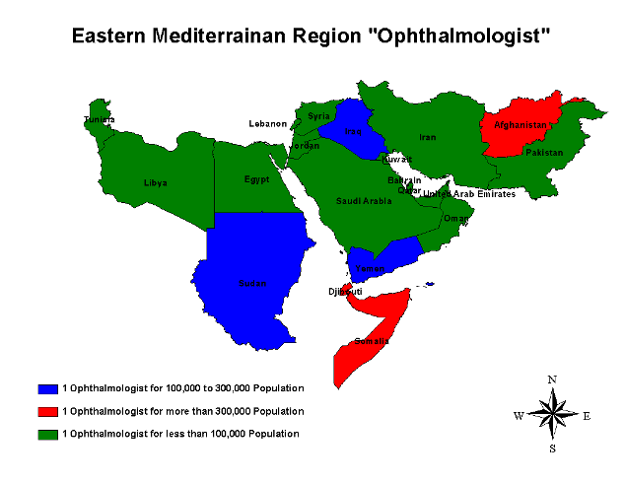

Proportion of countries in each category

**1 Ophthalmologist for 100,000 to 300,000 Population**

**1 Ophthalmologist more than 300,000 Population**

**1 Ophthalmologist for less than 100,000 Population**

|  |  |  |  |  |  |
| --- | --- | --- | --- | --- | --- |
|  | **Country** | **Total No. of**  **ophthalmologists** | **Current ophthalmologist: Population**  **ratio** | **Category** | **Number of ophthalmologists required to maintain the target ratio of 1: 100,000** |
| 1 | Afghanistan | 86 | 332255.8 | C | 286 |
| 2 | Bahrain | 36 | 19888.9 | A | - |
| 3 | Djibouti | 2 | 389500.0 | C | 8 |
| 4 | Egypt | 5240 | 13863.0 | A | - |
| 5 | Iran (Islamic Republic of) | 1230 | 55937.4 | A | - |
| 6 | Iraq | 140 | 200407.1 | B | 281 |
| 7 | Jordan | 231 | 24073.6 | A | - |
| 8 | Kuwait | 72 | 36194.4 | A | - |
| 9 | Lebanon | 219 | 16164.4 | A | - |
| 10 | Libyan Arab Jamahiriya | 170 | 33764.7 | A | - |
| 11 | Morocco | 1030 | 30116.5 | A | - |
| 12 | Oman | 104 | 24365.4 | A | - |
| 13 | Pakistan | 1860 | 83222.6 | A | - |
| 14 | Qatar | 32 | 24281.3 | A | - |
| 15 | Saudi Arabia | 361 | 66343.5 | A | - |
| 16 | Somalia | 3 | 2654666.7 | C | 80 |
| 17 | Sudan | 133 | 267090.2 | B | 356 |
| 18 | Syrian Arab Republic | 680 | 27326.5 | A | - |
| 19 | Tunisia | 358 | 27919.0 | A | - |
| 20 | United Arab Emirates | 108 | 39666.7 | A | - |
| 21 | Yemen | 203 | 100142.9 | B | 204 |
|  | **Regional aggregate** | **12298** | **42833.8** | **A** | **-** |

Table 16 Gap analysis in relation to the number of Ophthalmologists in EMR

**4.1.3.2 Optometrists**

The total number of optometrists in EMR amounts to 7369 with a population ration of 1 optometrist per 71485 population. The overall category as regards the presence of optometrist in the region is category A. However there is a possibility that because of lack of standardized definitions for various cadres of eye care personnel the definition specified in the template for optometrist could not have been followed by the resource personnel while sending the data, therefore the given number could be an overestimation of the total number of optometrists in each country. Moreover data was not available for 9 ( 42%) countries of the region.

As regards the presence of optometrist, the regional summary for EMR is given in table 17and details of all the countries in the region are summarized in table 18. Human resource availability for the cadre of optometrists in the region is presented in map 6. The findings of gap analysis regarding the number of optometrists in each country are summarized in table 19.

Table 17 Regional Summary of EMR regarding the availability of optometrists

|  |  |  |
| --- | --- | --- |
| **Category** | **Defining criteria** | **Number of countries** |
| **A** | 1 per <100,000 population | **6** |
| **B** | 1 per >=100,000-300,000 | **0** |
| **C** | 1 per > =300,000 | **6** |
| **D** | Data not available | **9** |

Table 18 Country-wise distribution of optometrists in EMR

|  |  |  |  |  |  |
| --- | --- | --- | --- | --- | --- |
|  | **Country** | **Population**  **(000)** | **Total No of**  **Optometrists** | **Population per optometrist** | **Category** |
| 1 | Afghanistan | 28574 | 35 | 816400.0 | C |
| 2 | Bahrain | 716 | - | - | D |
| 3 | Djibouti | 779 | 1 | 779000.0 | C |
| 4 | Egypt | 72642 | 3643 | 19940.2 | A |
| 5 | Iran (Islamic Republic of) | 68803 | 819 | 84008.5 | A |
| 6 | Iraq | 28057 | - | - | D |
| 7 | Jordan | 5561 | 1500 | 3707.3 | A |
| 8 | Kuwait | 2606 | - |  | D |
| 9 | Lebanon | 3540 | 135 | 26222.2 | A |
| 10 | Libyan Arab Jamahiriya | 5740 | - | - | D |
| 11 | Morocco | 31020 | - | - | D |
| 12 | Oman | 2534 | 42 | 60333.3 | A |
| 13 | Pakistan | 154794 | 30 | 5159800.0 | C |
| 14 | Qatar | 777 | - | - | D |
| 15 | Saudi Arabia | 23950 | 60 | 399166.7 | C |
| 16 | Somalia | 7964 | 4 | 1991000.0 | C |
| 17 | Sudan | 35523 | 1065 | 33354.9 | A |
| 18 | Syrian Arab Republic | 18582 | - | - | D |
| 19 | Tunisia | 9995 | - | - | D |
| 20 | United Arab Emirates | 4284 | - | - | D |
| 21 | Yemen | 20329 | 35 | 580828.6 | C |
|  | **Regional aggregate** | **526770** | **7369** | **71484.6** | **A** |

**Map 6: Country-wise distribution of optometrists in EMR**

empty

Map 6 Country-wise distribution of optometrists in EMR

empty



Proportion of countries in each category

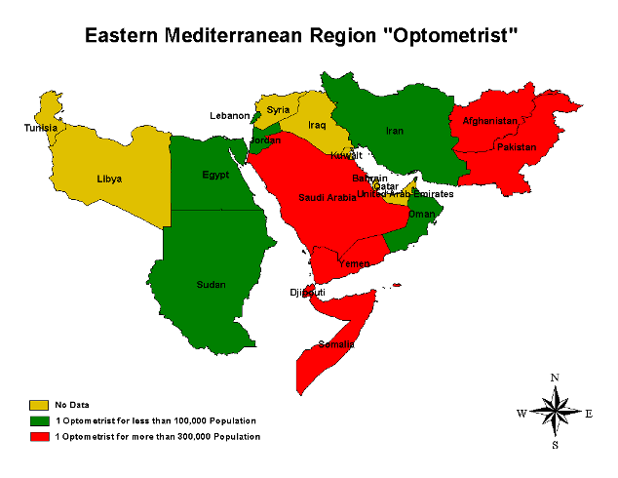

**No Data**

**1 Optometrist for less than 100,000 Population**

**1 Optometrist more than 300,000 Population**

Table 19 Gap analysis in relation to the number of optometrists in EMR

|  |  |  |  |  |  |
| --- | --- | --- | --- | --- | --- |
|  | **Country** | **Total No. of**  **Optometrists** | **Current Optometrist: Population**  **ratio** | **Category** | **Number of optometrists required to maintain the target ratio of 1:100,000** |
| 1 | Afghanistan | 35 | 816400.0 | C | 251 |
| 2 | Bahrain | - | - | D | 8 |
| 3 | Djibouti | 1 | 779000.0 | C | 7 |
| 4 | Egypt | 3643 | 19940.2 | A | - |
| 5 | Iran (Islamic Republic of) | 819 | 84008.5 | A | - |
| 6 | Iraq | - | - | D | 281 |
| 7 | Jordan | 1500 | 3707.3 | A | - |
| 8 | Kuwait | - |  | D | 27 |
| 9 | Lebanon | 135 | 26222.2 | A | - |
| 10 | Libyan Arab Jamahiriya | - | - | D | 58 |
| 11 | Morocco | - | - | D | 311 |
| 12 | Oman | 42 | 60333.3 | A | - |
| 13 | Pakistan | 30 | 5159800.0 | C | 1518 |
| 14 | Qatar | - | - | D | 8 |
| 15 | Saudi Arabia | 60 | 399166.7 | C | 180 |
| 16 | Somalia | 4 | 1991000.0 | C | 76 |
| 17 | Sudan | 1065 | 33354.9 | A | - |
| 18 | Syrian Arab Republic | - | - | D | 186 |
| 19 | Tunisia | - | - | D | 100 |
| 20 | United Arab Emirates | - | - | D | 43 |
| 21 | Yemen | 35 | 580828.6 | C | 169 |
|  | Regional aggregate | 7369 | 71484.6 | A | - |

**4.1.3.3. Ophthalmic Allied Personnel**

Regarding the availability of ophthalmic allied personnel, data was available for only 5 countries. The total number of allied personnel found in theses countries was 1,330 with a population ration of one allied person per 396,068 population. This placed the region with respect to the presence of allied personnel in the “C” category. This highlights not only the paucity of allied personnel but the mismatch between the number of ophthalmologists and the required number of allied personnel in the region.

The regional summary regarding situation concerning allied personnel is given in table 20 and details of all the countries in the region are summarized in table21. The information is mapped in map 7. The findings of gap analysis as regards the number of allied personnel in each country are summarized in table 22.

Table 20 Regional Summary of EMR regarding the availability of allied personnel

|  |  |  |  |  |
| --- | --- | --- | --- | --- |
| **Category** | **Defining criteria** | | **Number of countries** | |
| **A** | | 1 per <50,000 population | | **1** | |
| **B** | | 1 per >=50,000- <100,000 | | **2** | |
| **C** | | 1 per >=100,000 | | **2** | |
| **D** | | Data not available | | **16** | |

Table 21 Country-wise distribution of ophthalmic allied personnel in EMR

|  |  |  |  |  |  |
| --- | --- | --- | --- | --- | --- |
|  | **Country** | **Population**  **(000)** | **Total No of**  **Allied Personnel’s** | **Population per Allied Personnel** | **Category** |
| 1 | Afghanistan | 28574 | - | - | D |
| 2 | Bahrain | 716 | - | - | D |
| 3 | Djibouti | 779 | - | - | D |
| 4 | Egypt | 72642 | - | - | D |
| 5 | Iran (Islamic Republic of) | 68803 | - | - | D |
| 6 | Iraq | 28057 | - | - | D |
| 7 | Jordan | 5561 | - | - | D |
| 8 | Kuwait | 2606 | 204 | 12774.5098 | A |
| 9 | Lebanon | 3540 | - | - | D |
| 10 | Libyan Arab Jamahiriya | 5740 | 45 | 127555.5556 | C |
| 11 | Morocco | 31020 | - | - | D |
| 12 | Oman | 2534 | - | - | D |
| 13 | Pakistan | 154794 | 500 | 309588 | C |
| 14 | Qatar | 777 | - | - | D |
| 15 | Saudi Arabia | 23950 | 300 | 79833.33333 | B |
| 16 | Somalia | 7964 | - | - | D |
| 17 | Sudan | 35523 | - | - | D |
| 18 | Syrian Arab Republic | 18582 | - | - | D |
| 19 | Tunisia | 9995 | - | - | D |
| 20 | United Arab Emirates | 4284 | - | - | D |
| 21 | Yemen | 20329 | 281 | 72345.19573 | B |
|  | **Regional aggregate** | **526770** | **1330** | **396067.6692** | **C** |

Map 7 Country- wise distribution of Ophthalmic allied personnel in EMR

empty

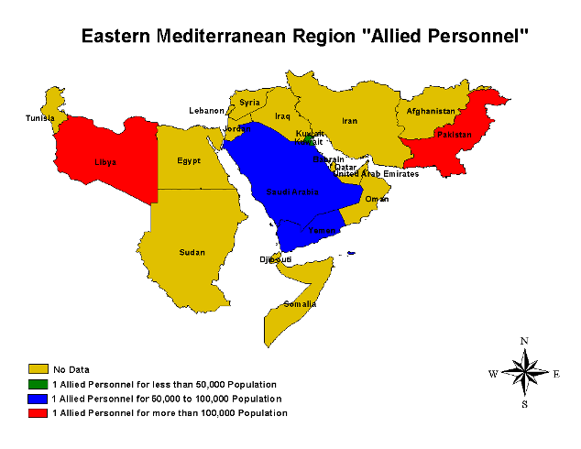

**No Data**

**1 Allied Personnel for less than 500,000 Population**

**1 Allied Personnel for 50,000 to 100,000 Population**

**1 Allied Personnel more than 100,000 Population**

Proportion of Ophthalmic allied personnel in EMR

Table 22 Gap analysis in relation to the number of Ophthalmic allied personnel in EMR

|  |  |  |  |  |  |
| --- | --- | --- | --- | --- | --- |
|  | **Country** | **Total No. of**  **Ophthalmic allied personnel** | **Current allied person: Population**  **ratio** | **Category** | **Number of allied personnel required to maintain the target ratio of 1: 50,000** |
| 1 | Afghanistan | - | - | D | 572 |
| 2 | Bahrain | - | - | D | 15 |
| 3 | Djibouti | - | - | D | 16 |
| 4 | Egypt | - | - | D | 1453 |
| 5 | Iran (Islamic Republic of) | - | - | D | 1377 |
| 6 | Iraq | - | - | D | 562 |
| 7 | Jordan | - | - | D | 112 |
| 8 | Kuwait | 204 | 12774.5098 | A | - |
| 9 | Lebanon | - | - | D | 71 |
| 10 | Libyan Arab Jamahiriya | 45 | 127555.5556 | C | 70 |
| 11 | Morocco | - | - | D | 621 |
| 12 | Oman | - | - | D | 51 |
| 13 | Pakistan | 500 | 309588 | C | 2596 |
| 14 | Qatar | - | - | D | 16 |
| 15 | Saudi Arabia | 300 | 79833.33333 | B | 179 |
| 16 | Somalia | - | - | D | 160 |
| 17 | Sudan | - | - | D | 711 |
| 18 | Syrian Arab Republic | - | - | D | 372 |
| 19 | Tunisia | - | - | D | 200 |
| 20 | United Arab Emirates | - | - | D | 86 |
| 21 | Yemen | 281 | 72345.19573 | B | 126 |
|  | **Regional aggregate** | **1330** | **396067.6692** | **C** | **9206** |

### 4.1.4. Europe

___________________________________________________________________________________________

**4.1.4.1 Ophthalmologists**

The data was available for only 42 countries in the region, from 11 countries the data could not be accessed. The total number of ophthalmologists in the region was found to be 42,647 with one ophthalmologist per 20,663 population. Forty –one countries of the region were categorized as in category A .No country was found to be in category C.

The regional summary regarding situation concerning ophthalmologists is given in table 23 and details of all the countries in the region are summarized in table24. The information is mapped in map 8. The findings of gap analysis as regards the number of ophthalmologists in each country are summarized in table 25.

Table 23 Regional Summary of Europe regarding number of ophthalmologists

|  |  |  |
| --- | --- | --- |
| **Category** | **Defining criteria** | **Number of countries** |
| **A** | 1 per < 50,000 population | **41** |
| **B** | 1 per >=50,000 to <100,000 | **1** |
| **C** | 1 per >= 100,000 | **0** |
| **D** | Data not available | **11** |

Table 24 Country-wise distribution of ophthalmologists in Europe

|  |  |  |  |  |  |
| --- | --- | --- | --- | --- | --- |
|  | **Country** | **Population**  **(000)** | **Total No. of**  **ophthalmologists** | **Population**  **Per**  **Ophthalmologist** | **Category** |
| 1 | Albania | 3112 | 70 | 44457.1429 | A |
| 2 | Andorra | 67 | - | - | D |
| 3 | Armenia | 3026 | 180 | 16811.1111 | A |
| 4 | Austria | 8171 | 720 | 11348.6111 | A |
| 5 | Azerbaijan | 8355 | 200 | 41775 | A |
| 6 | Belarus | 9811 | - | - | D |
| 7 | Belgium | 10400 | 926 | 11231.1015 | A |
| 8 | Bosnia and Herzegovina | 3909 | 116 | 33698.2759 | A |
| 9 | Bulgaria | 7780 | 300 | 25933.3333 | A |
| 10 | Croatia | 4540 | 403 | 11265.5087 | A |
| 11 | Cyprus | 826 | 65 | 12707.6923 | A |
| 12 | Czech Republic | 10229 | 1024 | 9989.25781 | A |
| 13 | Denmark | 5414 | 350 | 15468.5714 | A |
| 14 | Estonia | 1335 | 126 | 10595.2381 | A |
| 15 | Finland | 5235 | 571 | 9168.12609 | A |
| 16 | France | 60257 | - | - | D |
| 17 | Georgia | 4518 | 116 | 38948.2759 | A |
| 18 | Germany | 82645 | 4543 | 18191.7235 | A |
| 19 | Greece | 11098 | 870 | 12756.3218 | A |
| 20 | Hungary | 10124 | 600 | 16873.3333 | A |
| 21 | Iceland | 292 | - | - | D |
| 22 | Ireland | 4080 | 170 | 24000 | A |
| 23 | Israel | 6601 | 650 | 10155.3846 | A |
| 24 | Italy | 58033 | 2300 | 25231.7391 | A |
| 25 | Kazakhstan | 14839 | 583 | 25452.8302 | A |
| 26 | Kyrgyzstan | 5204 | 260 | 20015.3846 | A |
| 27 | Latvia | 2318 | 251 | 9235.05976 | A |
| 28 | Liechtenstein | - | - | - | D |

|  |  |  |  |  |  |
| --- | --- | --- | --- | --- | --- |
|  | **Country** | **Population**  **(000)** | **Total No. of**  **ophthalmologists** | **Population**  **Per**  **Ophthalmologist** | **Category** |
| 29 | Lithuania | 3443 | 350 | 9837.14286 | A |
| 30 | Luxembourg | 459 | - | - | D |
| 31 | Macedonia | 2050.554 | 160 | 12815.9625 | A |
| 32 | Malta | 400 | - | - | D |
| 33 | Monaco | 35 | - | - | D |
| 34 | Netherlands | 16226 | 916 | 17713.9738 | A |
| 35 | Norway | 4598 | - | - | D |
| 36 | Poland | 38559 | 1700 | 22681.7647 | A |
| 37 | Portugal | 10441 | 734 | 14224.7956 | A |
| 38 | Republic of Moldova | 4218 | - | - | D |
| 39 | Romania | 21790 | 821 | 26540.8039 | A |
| 40 | Russian Federation | 143899 | 5270 | 27305.3131 | A |
| 41 | San Marino | 28 | - | - | D |
| 42 | Serbia and Montenegro | 10510 | 640 | 16421.875 | A |
| 43 | Slovakia | 5401 | 370 | 14597.2973 | A |
| 44 | Slovenia | 1967 | 158 | 12449.3671 | A |
| 45 | Spain | 42646 | 3305 | 12903.4796 | A |
| 46 | Sweden | 9008 | 740 | 12172.973 | A |
| 47 | Switzerland | 7240 | 758 | 9551.45119 | A |
| 48 | Tajikistan | 6430 | 77 | 83506.4935 | B |
| 49 | Turkey | 72220 | 2800 | 25792.8571 | A |
| 50 | Turkmenistan | 4766 | 120 | 39716.6667 | A |
| 51 | Ukraine | 46989 | 3080 | 15256.1688 | A |
| 52 | United Kingdom | 59479 | 3200 | 18587.1875 | A |
| 53 | Uzbekistan | 26209 | 2054 | 12759.9805 | A |
|  | **Regional aggregate** | **881230.55** | **42647** | **20663.4** | **A** |

Map 8 Country –wise distribution of ophthalmologists in Europe

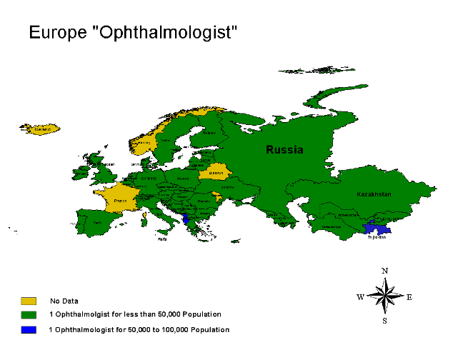

Proportion of countries in each category

**No Data**

**1 Ophthalmologist for less than 500,000 Population**

**1 Ophthalmologist for 50,000 to 100,000 Population**

empty

**Table 25 Gap analysis in relation to the number of Ophthalmologists in Europe**

|  |  |  |  |  |  |
| --- | --- | --- | --- | --- | --- |
|  | **Country** | **Total No. of**  **ophthalmologists** | **Current ophthalmologist: Population**  **ratio** | **Category** | **Number of ophthalmol required to maintain the target ratio of**  **1: 50,000** |
| 1 | Albania | 70 | 44457.1 | A | - |
| 2 | Andorra | - | - | D | 2 |
| 3 | Armenia | 180 | 16811.1 | A | - |
| 4 | Austria | 720 | 11348.6 | A | - |
| 5 | Azerbaijan | 200 | 41775.0 | A | - |
| 6 | Belarus | - | - | D | 197 |
| 7 | Belgium | 926 | 11231.1 | A | - |
| 8 | Bosnia and Herzegovina | 116 | 33698.3 | A | - |
| 9 | Bulgaria | 300 | 25933.3 | A | - |
| 10 | Croatia | 403 | 11265.5 | A | - |
| 11 | Cyprus | 65 | 12707.7 | A | - |
| 12 | Czech Republic | 1024 | 9989.3 | A | - |
| 13 | Denmark | 350 | 15468.6 | A | - |
| 14 | Estonia | 126 | 10595.2 | A | - |
| 15 | Finland | 571 | 9168.1 | A | - |
| 16 | France | - | - | D | 1206 |
| 17 | Georgia | 116 | 38948.3 | A | - |
| 18 | Germany | 4543 | 18191.7 | A | - |
| 19 | Greece | 870 | 12756.3 | A | - |
| 20 | Hungary | 600 | 16873.3 | A | - |
| 21 | Iceland | - | - | D | 6 |
| 22 | Ireland | 170 | 24000.0 | A | - |
| 23 | Israel | 650 | 10155.4 | A | - |
| 24 | Italy | 2300 | 25231.7 | A | - |
| 25 | Kazakhstan | 583 | 25452.8 | A | - |
| 26 | Kyrgyzstan | 260 | 20015.4 | A | - |
| 27 | Latvia | 251 | 9235.1 | A | - |
| 28 | Liechtenstein | - | - | D | - |
|  | **Country** | **Total No. of**  **ophthalmologists** | **Current ophthalmologist: Population**  **ratio** | Category | **Number of ophthalmol required to maintain the target ratio of**  **1: 50,000** |
| 29 | Lithuania | 350 | 9837.1 | A | - |
| 30 | Luxembourg | - | - | D | 10 |
| 31 | Macedonia | 160 | 12816.0 | A | - |
| 32 | Malta | - | - | D | 8 |
| 33 | Monaco | - | - | D | 1 |
| 34 | Netherlands | 916 | 17714.0 | A | - |
| 35 | Norway | - | - | D | 92 |
| 36 | Poland | 1700 | 22681.8 | A | - |
| 37 | Portugal | 734 | 14224.8 | A | - |
| 38 | Republic of Moldova | - | - | D | 85 |
| 39 | Romania | 821 | 26540.8 | A | - |
| 40 | Russian Federation | 5270 | 27305.3 | A | - |
| 41 | San Marino | - | - | D | 1 |
| 42 | Serbia and Montenegro | 640 | 16421.9 | A | - |
| 43 | Slovakia | 370 | 14597.3 | A | - |
| 44 | Slovenia | 158 | 12449.4 | A | - |
| 45 | Spain | 3305 | 12903.5 | A | - |
| 46 | Sweden | 740 | 12173.0 | A | - |
| 47 | Switzerland | 758 | 9551.5 | A | - |
| 48 | Tajikistan | 77 | 83506.5 | B | 129 |
| 49 | Turkey | 2800 | 25792.9 | A | - |
| 50 | Turkmenistan | 120 | 39716.7 | A | - |
| 51 | Ukraine | 3080 | 15256.2 | A | - |
| 52 | United Kingdom | 3200 | 18587.2 | A | - |
| 53 | Uzbekistan | 2054 | 12760.0 | A | - |
|  | **Regional aggregate** | **42647** | **20663.4** | **A** | **-** |

**4.1.4.2. Other eye care personnel**

Reliable data concerning other cadres of eye care personnel including optometrists was not available for the region therefore no further analysis could be done in this respect.

### 4.1.5. South-East Asia

**____________________________________________________________________________________**

**4.1.5. South-East Asia**

**4.1.5.1. Ophthalmologists**

The data was available for 9 countries(81.81%) of the region. The information about only two countries was not available. The total number of ophthalmologists in the region was 13,348 with one ophthalmologist per 122, 339 population. Therefore the region was placed in “B” category. There were 3 (27.27%) countries in each of the categories of A, B and C.

As regards the presence of ophthalmologists, the regional summary for South-East Asia is given in table 26 and details of all the countries in the region are summarized in table 27. Human resource availability for the cadre of ophthalmologist in the region is presented in map 9. The findings of gap analysis regarding the number of ophthalmologists in each country are summarized in table 28.

Table 26 Regional Summary of South-East Asia regarding the availability of ophthalmologists

|  |  |  |
| --- | --- | --- |
| **Category** | **Defining criteria** | **Number of countries** |
| A | 1 per <100,000 population | **3** |
| B | 1 per >=100,000-300,000 | **3** |
| C | 1 per > =300,000 | **3** |
| D | Data not available | **2** |

Table 27 Country – wise distribution of ophthalmologists in South-East Asia

|  |  |  |  |  |  |
| --- | --- | --- | --- | --- | --- |
|  | **Country** | **Population**  **(000)** | **Total No. of**  **ophthalmologists** | **Population per Ophthalmol.** | **Category** |
| 1 | Bangladesh | 139215 | 626 | 222388.2 | B |
| 2 | Bhutan | 2116 | 3 | 705333.3 | C |
| 3 | India | 1087124 | 11,000 | 98829.5 | A |
| 4 | Indonesia | 220077 | 750 | 293436.0 | B |
| 5 | Democratic People's republic of Korea | 22384 | - | - | D |
| 6 | Maldives | 321 | 6 | 53500.0 | A |
| 7 | Myanmar | 50004 | 166 | 301228.9 | C |
| 8 | Nepal | 26591 | 110 | 241736.4 | B |
| 9 | Sri Lanka | 20570 | 40 | 514250.0 | C |
| 10 | Thailand | 63694 | 647 | 98445.1 | A |
| 11 | Timor L'este (East Timor) | 887 | - | - | D |
|  | **Regional aggregate** | **1632983** | **13348** | **122339.2** | **B** |

Map 9 Country-wise distribution of ophthalmologists in SEA

empty

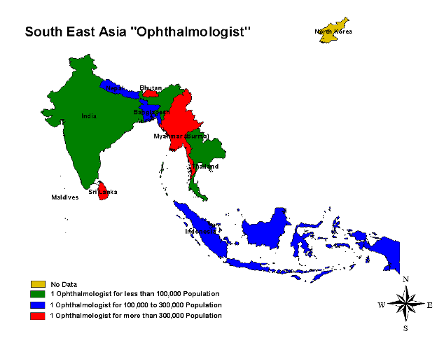

Proportion of countries in each category

**No Data**

**1 Ophthalmologist for less than 100,000 Population**

**1 Ophthalmologist for 100,000 to 300,000 Population**

**1 Ophthalmologist more than 300,000 Population**

Table 28 Gap analysis in relation to the number of Ophthalmologist in SEA

|  |  |  |  |  |  |
| --- | --- | --- | --- | --- | --- |
|  | **Country** | **Total No. of**  **ophthalmologists** | **Current ophthalmologist: Population**  **ratio** | **Category** | **Number of ophthalmologists required to maintain the target ratio of 1:100,000 population** |
| 1 | Bangladesh | 626 | 222388.2 | B | 1393 |
| 2 | Bhutan | 3 | 705333.3 | C | 22 |
| 3 | India | 11,000 | 98829.5 | A | 10872 |
| 4 | Indonesia | 750 | 293436.0 | B | 2201 |
| 5 | Democratic People's republic of Korea | - | - | D | 224 |
| 6 | Maldives | 6 | 53500.0 | A | 4 |
| 7 | Myanmar | 166 | 301228.9 | C | 501 |
| 8 | Nepal | 110 | 241736.4 | B | 266 |
| 9 | Sri Lanka | 40 | 514250.0 | C | 206 |
| 10 | Thailand | 647 | 98445.1 | A | 637 |
| 11 | Timor L'este (East Timor) | - | - | D | 9 |
|  | **Regional aggregate** | **13348** | **122339.2** | **B** | **16330** |

**4.1.5.2. Optometrists**

Regarding the data concerning optometrists, no reliable details could be accessed therefore further analysis was not possible.

**4.1.5.3. Ophthalmic allied personnel**

Data concerning the availability of ophthalmic allied personnel was available for 9 (81.81%) of the 11 countries in the region. The overall population ratio was one ophthalmic allied person per 78,111 population, placing SEA in the B category. Most of the countries (6, 55%) belonged to the category B, 3 countries were found to be in the C category while none in the A category.

As regards the presence of ophthalmic allied personnel, the regional summary for SEA is given in table 29 and details of all the countries in the region are summarized in table 30. Human resource availability for the cadre of allied personnel in the region is presented in map 10. The findings of gap analysis regarding the number of ophthalmic allied personnel in each country are summarized in table 31.

Table 29 Regional Summary of SEA regarding the availability of Ophthalmic allied personnel

|  |  |  |
| --- | --- | --- |
| **Category** | **Defining criteria** | **Number of countries** |
| **A** | 1 per < 50,000 population | **0** |
| **B** | 1 per >=50,000 to <100,000 | **6** |
| **C** | 1 per >= 100,000 | **3** |
| **D** | Data not available | **2** |

Table 30 Country-wise distribution of ophthalmic allied personnel SEA

|  |  |  |  |  |  |
| --- | --- | --- | --- | --- | --- |
|  | **Country** | **Population**  **(000)** | **No of**  **Allied Personnel** | **Population per**  **allied** | **Category** |
| 1 | Bangladesh | 139215 | 471 | 295573.2 | C |
| 2 | Bhutan | 2116 | 19 | 111368.4 | C |
| 3 | India | 1087124 | 15,000 | 72474.9 | B |
| 4 | Indonesia | 220077 | 3600 | 61132.5 | B |
| 5 | Democratic People's republic of Korea | 22384 | - | - | D |
| 6 | Maldives | 321 | 5 | 64200.0 | B |
| 7 | Myanmar | 50004 | 200 | 250020.0 | C |
| 8 | Nepal | 26591 | 450 | 59091.1 | B |
| 9 | Sri Lanka | 20570 | 290 | 70931.0 | B |
| 10 | Thailand | 63694 | 871 | 73127.4 | B |
| 11 | Timor L'este (East Timor) | 887 | - | - | D |
|  | **Regional aggregate** | **1632983** | **20906** | **78110.7** | **B** |

Map 10 Country-wise distribution of ophthalmic allied personnel in South –East Asia

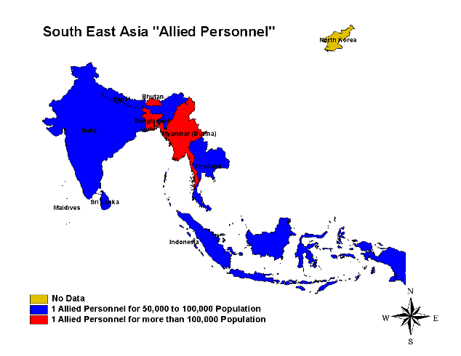

Proportion of countries in each category

**No Data**

**1 Allied Personnel for 50,000 to 100,000 Population**

**1 Allied Personnel more than 100,000 Population**

empty

Table 31 Gap analysis in relation to the number of ophthalmic allied personnel in SEA

|  |  |  |  |  |  |
| --- | --- | --- | --- | --- | --- |
|  | **Country** | **Total No. of**  **Ophthalmic allied personnel** | **Current allied personnel: Population**  **ratio** | **Category** | **Number of allied personnel required to maintain the target ratio of 1: 100,000** |
| 1 | Bangladesh | 471 | 295573.2 | C | 2785 |
| 2 | Bhutan | 19 | 111368.4 | C | 43 |
| 3 | India | 15,000 | 72474.9 | B | 21743 |
| 4 | Indonesia | 3600 | 61132.5 | B | 4402 |
| 5 | Democratic People's republic of Korea | - | - | D | 448 |
| 6 | Maldives | 5 | 64200.0 | B | 7 |
| 7 | Myanmar | 200 | 250020.0 | C | 1001 |
| 8 | Nepal | 450 | 59091.1 | B | 532 |
| 9 | Sri Lanka | 290 | 70931.0 | B | 412 |
| 10 | Thailand | 871 | 73127.4 | B | 1274 |
| 11 | Timor L'este (East Timor) | - | - | D | 18 |
|  | **Regional aggregate** | **20906** | **78110.7** | **B** | **32660** |

### 4.1.6. Western Pacific

**___________________________________________________________________________________**

**4.1.6.1. Ophthalmologists**

The information concerning ophthalmologists was available for 13 (46%) countries of WPR, data was not available for further analysis for 8 (29%) countries. The total number of ophthalmologists in the region was 42,158 with one ophthalmologist per 41,803 people. Hence the region was placed in A category. Almost half of the countries ( 13, 46%) belonged to A category.

As regards the presence of ophthalmologists, the regional summary for WPR is given in table 32 and details of all the countries in the region are summarized in table 33. Human resource availability for the cadre of ophthalmologist in the region is presented in map 11. The findings of gap analysis regarding the number of ophthalmologists in each country are summarized in table 34.

Table 32 Regional Summary of WPR regarding the availability of ophthalmologists

|  |  |  |
| --- | --- | --- |
| **Category** | **Defining criteria** | **Number of countries** |
| **A** | 1 per <100,000 population | **13** |
| **B** | 1 per >=100,000-300,000 | **5** |
| **C** | 1 per > =300,000 | **2** |
| **D** | Data not available | **8** |

Table 33 Country-wise distribution of ophthalmologists in WPR

|  |  |  |  |  |  |
| --- | --- | --- | --- | --- | --- |
|  | **Country** | **Population**  **(000)** | **No. of**  **ophthalmologists** | **Ophthalmol**  **Per population** | **Category** |
| 1 | Australia | 19942 | 895 | 22281.6 | A |
| 2 | Brunei Darussalam | 366 | 10 | 36600 | A |
| 3 | Cambodia | 13798 | 32 | 431188 | C |
| 4 | China, Hong Kong and Macao | 1315409 | 22,100 | 59520.8 | A |
| 5 | Cook Islands (N.Z.) | 18 | - | - | D |
| 6 | Fiji | 841 | 12 | 70083.3 | A |
| 7 | Japan | 127923 | 13,413 | 9537.24 | A |
| 8 | Kiribati | 97 | - | - | D |
| 9 | Republic of Korea (South Korea) | 47645 | 2026 | 23516.8 | A |
| 10 | Lao People's Democratic Republic | 5792 | 22 | 263273 | B |
| 11 | Malaysia | 24894 | 294 | 84673.5 | A |
| 12 | Marshall Islands | 60 | - | - | D |
| 13 | Micronesia | 110 | - | - | D |
| 14 | Mongolia | 2614 | 97 | 26948.5 | A |
| 15 | Nauru | 13 | - | - | D |
| 16 | New Zealand | 3989 | 104 | 38355.8 | A |
| 17 | Niue (N.Z) (washed out) | - | - | - | D |
| 18 | Palau | 20 | - | - | D |
| 19 | Papua New Guinea | 5772 | 9 | 641333 | C |
| 20 | Philippines | 81617 | 1467 | 55635.3 | A |
| 21 | Samoa | 184 | 2 | 92000 | A |
| 22 | Singapore | 4273 | 131 | 32618.3 | A |
| 23 | Solomon Islands | 466 | 2 | 233000 | B |
| 24 | Taiwan | 23036 | 1040 | 22150.1 | A |
| 25 | Tonga | 102 | 1 | 102000 | B |
| 26 | Tuvalu | 10 | - | - | D |
| 27 | Vanuatu | 207 | 1 | 207000 | B |
| 28 | Vietnam | 83123 | 500 | 166246 | B |
|  | **Regional aggregate** | **1739285** | **42158** | **41256.35** | **A** |

Map 11 Country- wise distribution of ophthalmologists in WPR

empty

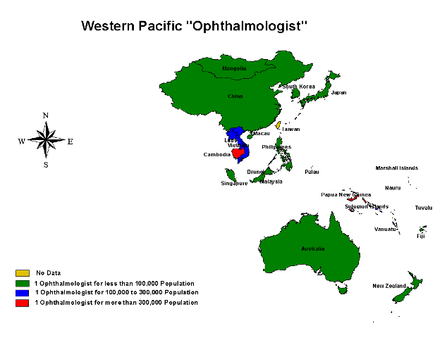

Proportion of countries in each category

Proportion of countries in each category

**No Data**

**1 Ophthalmologist for less than 100,000 Population**

**1 Ophthalmologist for 100,000 to 300,000 Population**

**1 Ophthalmologist for more than 300,000 Population**

Table 34 Gap analysis in relation to the number of Ophthalmologists in WPR

|  |  |  |  |  |  |
| --- | --- | --- | --- | --- | --- |
|  | **Country** | **Total No. of**  **Ophthalmol.** | **Current Ophthalmol: Population**  **ratio** | **Category** | **Number of Ophthalmol. required to maintain the target ratio of**  **1: 100,000** |
| 1 | Australia | 895 | 22281.6 | A | - |
| 2 | Brunei Darussalam | 10 | 36600 | A | - |
| 3 | Cambodia | 32 | 431188 | C | 137.980 |
| 4 | China, Hong Kong and Macao | 22,100 | 59520.8 | A | - |
| 5 | Cook Islands (N.Z.) | - | - | D | 0.180 |
| 6 | Fiji | 12 | 70083.3 | A | - |
| 7 | Japan | 13,413 | 9537.24 | A | - |
| 8 | Kiribati | - | - | D | 0.970 |
| 9 | Republic of Korea (South Korea) | 2026 | 23516.8 | A | - |
| 10 | Lao People's Democratic Republic | 22 | 263273 | B | 57.920 |
| 11 | Malaysia | 294 | 84673.5 | A | - |
| 12 | Marshall Islands | - | - | D | 0.600 |
| 13 | Micronesia | - | - | D | 1.100 |
| 14 | Mongolia | 97 | 26948.5 | A | - |
| 15 | Nauru | - | - | D | 0.130 |
| 16 | New Zealand | 104 | 38355.8 | A | - |
| 17 | Niue (N.Z) (washed out) | - | - | D | - |
| 18 | Palau | - | - | D | 0.200 |
| 19 | Papua New Guinea | 9 | 641333 | C | 57.720 |
| 20 | Philippines | 1467 | 55635.3 | A | - |
| 21 | Samoa | 2 | 92000 | A | - |
| 22 | Singapore | 131 | 32618.3 | A | - |

|  |  |  |  |  |  |
| --- | --- | --- | --- | --- | --- |
|  | **Country** | **Total No. of**  **Ophthalmol.** | **Current Ophthalmol: Population**  **ratio** | **Category** | **Number of Ophthalmol. required to maintain the target ratio of**  **1: 100,000** |
| 23 | Solomon Islands | 2 | 233000 | B | 4.660 |
| 24 | Taiwan | 1040 | - | D | - |
| 25 | Tonga | 1 | 102000 | B | 1.020 |
| 26 | Tuvalu | - | - | D | 0.100 |
| 27 | Vanuatu | 1 | 207000 | B | 2.070 |
| 28 | Vietnam | 500 | 166246 | B | 831.230 |
|  | Regional aggregate | 42158 | 41256.35 | A | - |

**4.1.6.2. Optometrists**

The data concerning optometrists was available for only 5 (18%) countries of WPR, while it was not available for analysis for the rest of the 23 (82%) countries. The total number of optometrists in the countries for which the data could be accessed was4039 with one optometrist per 430,623 population hence WPR was placed in the C category. However the data is too insufficient to be of any significance.

As regards the presence of optometrists, the regional summary for WPR is given in table 35 and details of all the countries in the region are summarized in table 36. Human resource availability for the cadre of optometrists in the region is presented in map 12. The findings of gap analysis regarding the number of optometrists in each country are summarized in table 37.

Table 35 Regional Summary of WPR regarding the availability of optometrist

|  |  |  |
| --- | --- | --- |
| **Category** | **Defining criteria** | **Number of countries** |
| **A** | 1 per <100,000 population | **2** |
| **B** | 1 per >=100,000-300,000 | **2** |
| **C** | 1 per > =300,000 | **1** |
| **D** | Data not available | **23** |

Table 36 Country-wise distribution of optometrists in WPR

|  |  |  |  |  |  |
| --- | --- | --- | --- | --- | --- |
|  | **Country** | **Population**  **(000)** | **Total No. of Optometrists** | **Population per optometrist** | **Category** |
| 1 | Australia | 19942 | 3500 | 5697.71429 | A |
| 2 | Brunei Darussalam | 366 | 2 | 183000 | B |
| 3 | Cambodia | 13798 | - | - | D |
| 4 | China, Hong Kong and Macao | 1315409 | - | - | D |
| 5 | Cook Islands (N.Z.) | 18 | - | - | D |
| 6 | Fiji | 841 | 7 | 120142.857 | B |
| 7 | Japan | 127923 | - | - | D |
| 8 | Kiribati | 97 | - | - | D |
| 9 | Republic of Korea (South Korea) | 47645 | - | - | D |
| 10 | Lao People's Democratic Republic | 5792 | - | - | D |
| 11 | Malaysia | 24894 | 529 | 47058.6011 | A |
| 12 | Marshall Islands | 60 | - | - | D |
| 13 | Micronesia | 110 | - | - | D |
| 14 | Mongolia | 2614 | - | - | D |
| 15 | Nauru | 13 | - | - | D |
| 16 | New Zealand | 3989 | - | - | D |
| 17 | Niue (N.Z) (washed out) |  | - | - | D |
| 18 | Palau | 20 | - | - | D |
| 19 | Papua New Guinea | 5772 | - | - | D |
| 20 | Philippines | 81617 | - | - | D |
| 21 | Samoa | 184 | - | - | D |
| 22 | Singapore | 4273 | - | - | D |
| 23 | Solomon Islands | 466 | 1 | 466000 | C |
| 24 | Taiwan | - | - | - | D |

|  |  |  |  |  |  |
| --- | --- | --- | --- | --- | --- |
|  | **Country** | **Population**  **(000)** | **Total No. of Optometrists** | **Population per optometrist** | **Category** |
| 25 | Tonga | 102 | - | - | D |
| 26 | Tuvalu | 10 | - | - | D |
| 27 | Vanuatu | 207 | - | - | D |
| 28 | Vietnam | 83123 | - | - | D |
|  | **Regional aggregate** | **1739285** | **4039** | **430622.679** | **C** |

Map 12 Country-wise distribution of optometrists in WPR

empty

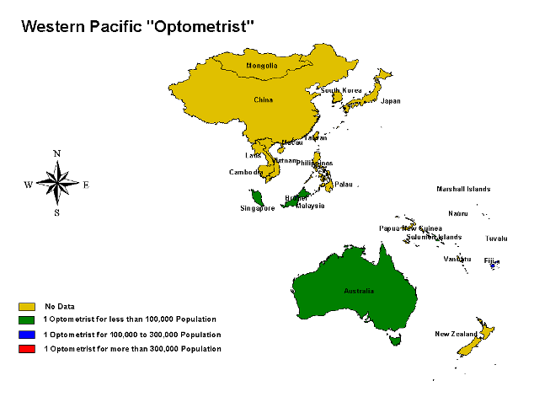

Proportion of countries I each category

**No Data**

**1 Optometrist for less than 100,000 Population**

**1 Optometrist for 100,000 to 300,000 Population**

**1 Optometrist for more than 300,000 Population**

Table 37 Gap analysis in relation to the number of Optometrist in WPR

|  |  |  |  |  |  |
| --- | --- | --- | --- | --- | --- |
|  | **Country** | **Total No. of**  **Optomet.** | **Current Optomet: Population**  **ratio** | **Category** | **Number of Optomet. required to maintain the target ratio of**  **1: 100,000** |
| 1 | Australia | 3500 | 5697.71429 | A | - |
| 2 | Brunei Darussalam | 2 | 183000 | B | 3.660 |
| 3 | Cambodia | - | - | D | 137.980 |
| 4 | China, Hong Kong and Macao | - | - | D | 13154.090 |
| 5 | Cook Islands (N.Z.) | - | - | D | 0.180 |
| 6 | Fiji | 7 | 120142.857 | B | 8.410 |
| 7 | Japan | - | - | D | 1279.230 |
| 8 | Kiribati | - | - | D | 0.970 |
| 9 | Republic of Korea (South Korea) | - | - | D | 476.450 |
| 10 | Lao People's Democratic Republic | - | - | D | 57.920 |
| 11 | Malaysia | 529 | 47058.6011 | A | - |
| 12 | Marshall Islands | - | - | D | 0.600 |
| 13 | Micronesia | - | - | D | 1.100 |
| 14 | Mongolia | - | - | D | 26.140 |
| 15 | Nauru | - | - | D | 0.130 |
| 16 | New Zealand | - | - | D | 39.890 |
| 17 | Niue (N.Z) (washed out) | - | - | D | - |
| 18 | Palau | - | - | D | 0.200 |
| 19 | Papua New Guinea | - | - | D | 57.720 |
| 20 | Philippines | - | - | D | 816.170 |
| 21 | Samoa | - | - | D | 1.840 |
| 22 | Singapore | - | - | D | 42.730 |
| 23 | Solomon Islands | 1 | 466000 | C | 4.660 |
| 24 | Taiwan | - | - | D | 0.000 |
|  | **Country** | **Total No. of**  **Optomet.** | **Current Optomet: Population**  **ratio** | **Category** | **Number of Optomet. required to maintain the target ratio of**  **1: 100,000** |
| 25 | Tonga | - | - | D | 1.020 |
| 26 | Tuvalu | - | - | D | 0.100 |
| 27 | Vanuatu | - | - | D | 2.070 |
| 28 | Vietnam | - | - | D | 831.230 |
|  | Regional aggregate | 4039 | 430622.679 | C | 17392.850 |

**4.1.6.3. Ophthalmic Allied Personnel**

Data was available for only 12 (43%) of the 28 countries hence any meaningful analysis was not possible however preliminary analysis of the available information is presented. There were a total of 21,431 allied personnel in the region with one allied person per 81,157 population , placing the region in the B category. Most of the countries for which the data was available was found to be in the A category i.e. 10 ( 83%) out of the 12 countries.

As regards the presence of ophthalmic allied personnel, the regional summary for WPR is given in table 38 and details of all the countries in the region are summarized in table 39. Human resource availability for the cadre of allied personnel in the region is illustrated in map 13. The findings of gap analysis regarding the number of allied personnel in each country are summarized in table 40.

Table 38 Regional Summary of WPR regarding the availability of allied personnel

|  |  |  |
| --- | --- | --- |
| **Category** | **Defining criteria** | **Number of countries** |
| **A** | 1 per < 50,000 population | **10** |
| **B** | 1 per >=50,000 to <100,000 | **0** |
| **C** | 1 per >= 100,000 | **2** |
| **D** | Data not available | **16** |

Table 39 Country-wise distribution of Ophthalmic allied personnel in WPR

|  |  |  |  |  |  |
| --- | --- | --- | --- | --- | --- |
|  | **Country** | **Population**  **(000)** | **Total No. of allied personnel** | **Population**  **per**  **allied person** | **Category** |
| 1 | Australia | 19942 | 850 | 23461.2 | A |
| 2 | Brunei Darussalam | 366 | - | - | D |
| 3 | Cambodia | 13798 | 68 | 202911.8 | C |
| 4 | China, Hong Kong and Macao | 1315409 | - | - | D |
| 5 | Cook Islands (N.Z.) | 18 |  |  | D |
| 6 | Fiji | 841 | 22 | 38227.3 | A |
| 7 | Japan | 127923 | - | - | D |
| 8 | Kiribati | 97 | - | - | D |
| 9 | Republic of Korea (South Korea) | 47645 | - | - | D |
| 10 | Lao People's Democratic Republic | 5792 | 200 | 28960.0 | A |
| 11 | Malaysia | 24894 | 2650 | 9394.0 | A |
| 12 | Marshall Islands | 60 | - | - | D |
| 13 | Micronesia | 110 | - | - | D |
| 14 | Mongolia | 2614 | - | - | D |
| 15 | Nauru | 13 | - | - | D |
| 16 | New Zealand | 3989 | 520 | 7671.2 | A |
| 17 | Niue (N.Z) (washed out) | - | - | - | D |
| 18 | Palau | 20 | - | - | D |
| 19 | Papua New Guinea | 5772 | - | - | D |
| 20 | Philippines | 81617 | - | - | D |
| 21 | Samoa | 184 | 1 | 184000.0 | C |
| 22 | Singapore | 4273 | - | - | D |
| 23 | Solomon Islands | 466 | 24 | 19416.7 | A |
| 24 | Taiwan | - | - | - | D |
| 25 | Tonga | 102 | 3 | 34000.0 | A |
| 26 | Tuvalu | 10 | 1 | 10000.0 | A |
| 27 | Vanuatu | 207 | 11 | 18818.2 | A |
| 28 | Vietnam | 83123 | 17081 | 4866.4 | A |
|  | **Regional aggregate** | **1739285** | **21431** | **81157.4** | **B** |

Map 13 Country- wise distribution of Ophthalmic allied personnel in WPR

empty

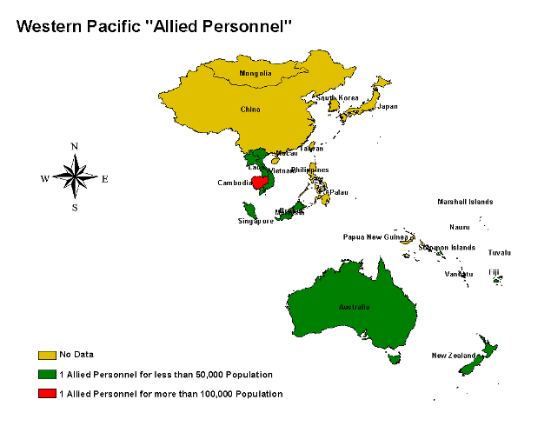

Proportion of countries in each category

**No Data**

**1 Allied Personnel for less than 50,000 Population**

**1 Allied Personnel for more than 100,000 Population**

Table 40 Gap analysis in relation to the number of allied personnel in WPR

|  |  |  |  |  |  |
| --- | --- | --- | --- | --- | --- |
|  | **Country** | **Total No. of**  **Allied personnel** | **Current allied personnel: Population**  **ratio** | **Category** | **Number of allied personnel required to maintain the target ratio of**  **1: 50,000** |
| 1 | Australia | 850 | 23461.2 | A | - |
| 2 | Brunei Darussalam |  |  | D | 8 |
| 3 | Cambodia | 68 | 202911.8 | C | 276 |
| 4 | China, Hong Kong and Macao | - | - | D | 26309 |
| 5 | Cook Islands (N.Z.) |  |  | D | 1 |
| 6 | Fiji | 22 | 38227.3 | A | 17 |
| 7 | Japan | - | - | D | 2559 |
| 8 | Kiribati | - | - | D | 2 |
| 9 | Republic of Korea (South Korea) | - | - | D | 953 |
| 10 | Lao People's Democratic Republic | 200 | 28960.0 | A | 116 |
| 11 | Malaysia | 2650 | 9394.0 | A | 498 |
| 12 | Marshall Islands | - | - | D | 2 |
| 13 | Micronesia | - | - | D | 3 |
| 14 | Mongolia | - | - | D | 53 |
| 15 | Nauru | - | - | D | 1 |
| 16 | New Zealand | 520 | 7671.2 | A | 80 |
| 17 | Niue (N.Z) (washed out) | - | - | D | - |
| 18 | Palau | - | - | D | 1 |
| 19 | Papua New Guinea | - | - | D | 116 |
| 20 | Philippines | - | - | D | 1633 |
| 21 | Samoa | 1 | 184000.0 | C | 4 |
| 22 | Singapore | - | - | D | 86 |

|  |  |  |  |  |  |
| --- | --- | --- | --- | --- | --- |
|  | **Country** | **Total No. of**  **Allied personnel** | **Current allied personnel: Population**  **ratio** | **Category** | **Number of allied personnel required to maintain the target ratio of**  **1: 50,000** |
| 23 | Solomon Islands | 24 | 19416.7 | A | 10 |
| 24 | Taiwan | - | - | D | - |
| 25 | Tonga | 3 | 34000.0 | A | 3 |
| 26 | Tuvalu | 1 | 10000.0 | A | 1 |
| 27 | Vanuatu | 11 | 18818.2 | A | 5 |
| 28 | Vietnam | 17081 | 4866.4 | A | 1663 |
|  | Regional aggregate | 21431 | 81157.4 | B | 34786 |

Table 41 Summary of all regions

|  |  |  |  |  |  |  |
| --- | --- | --- | --- | --- | --- | --- |
|  | Africa | Americas | EMR | Europe | SEA | WPR |
| **Ophthalmologists** | | | | | | |
| **Total number** | **2210** | **45,700** | **12,298** | **42,647** | **13,348** | **42,158** |
| **Population ratio** | **1:326677** | **1:19,160** | **1:42834** | **1:20,663** | **1:122339** | **1:41256** |
| **Category** | **A** | **A** | **A** | **A** | **B** | **A** |
| **Data not available for** | **1** | **1** | **0** | **11** | **2** | **8** |
| **Optometrists** | | | | | | |
| **Total number** | **1690** | **-----** | **7369** | **-----** | **----** | **4039** |
| **Population ratio** | **1:427192** | **-----** | **1:71485** | **-----** | **----** | **1:430623** |
| **Category** | **B** | **-----** | **A** | **-----** | **----** | **C** |
| **Data not available for** | **25** | **-----** | **9** | **-----** | **----** | **23** |
| **Ophthalmic allied personnel** | | | | | | |
| **Total number** | **7253** | **-----** | **1330** | **-----** | **20,906** | **21,431** |
| **Population ratio** | **1:99539** | **-----** | **1:396068** | **-----** | **1:78111** | **1:81157** |
| **Category** | **A** | **----** | **C** | **----** | **B** | **B** |
| **Data not available for** | **6** | **----** | **16** | **----** | **2** | **16** |

An important fact highlighted from the given data is that most of the countries that were expected to have greater need could not provide their data. In fact this reflects the inadequacy of organized eye care services. Contrary to this Europe and Americas also could not provide updated data. The disparity between the number of ophthalmologists and the corresponding number of ophthalmic nurses and allied personnel is found to be a ubiquitous phenomenon.

## 4.2. Training Institutes for Eye-care personnel

**____________________________________________________________________________________**

Very little information regarding training institutes was available, however we were able to benefit from a sufficiently detailed Vision 2020 directory of training institutes for eye care personnel ( given in annex 4). Whatever additional information was collected during this study has been given as annex 5 under training institutes for ophthalmologists, community eye health personnel ( doctors and nurse) and allied personnel ( all other cadres).

The training institutes are geographically mapped under various regions in map 14 to 19.

Map 14 Training Institutes in Africa

empty

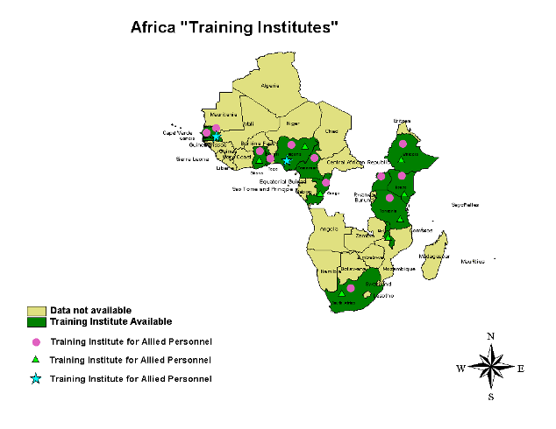

**Training institutes for allied personnel**

**Training institutes for ophthalmologists**

**Training institutes for Community Eye Health**

**Data not available**

**Training Institute Available**

Map 15 Training Institute in Americas

empty

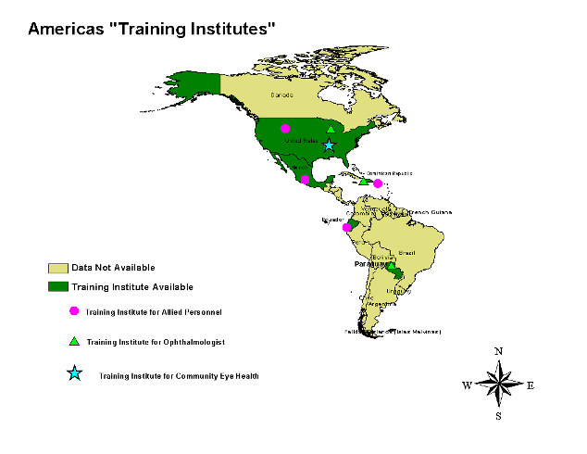

**Training institutes for allied personnel**

**Training institutes for ophthalmologists**

**Training institutes for Community Eye Health**

**Data not available**

**Training Institute Available**

Map 16 Training Institutes in EMR

empty

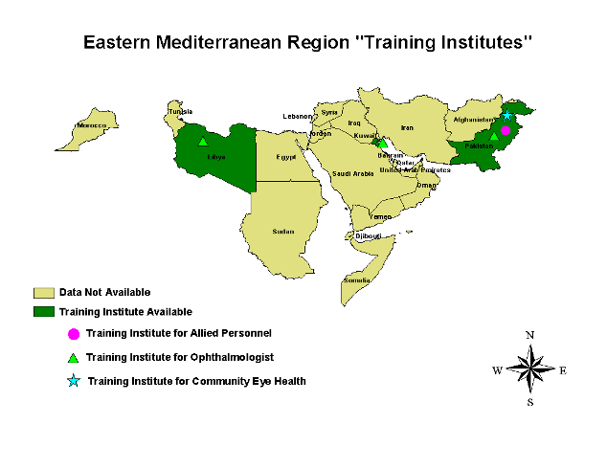

**Training institutes for allied personnel**

**Training institutes for ophthalmologists**

**Training institutes for Community Eye Health**

**Data not available**

**Training Institute Available**

Map 17 Training Institutes in Europe

empty

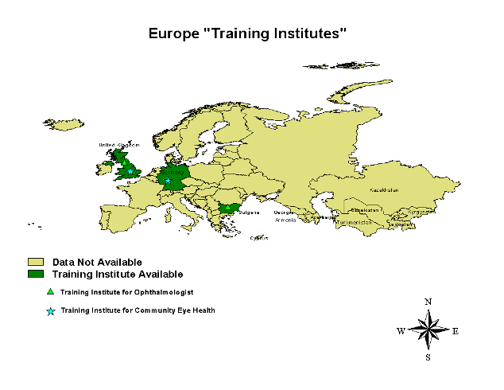

**Training institutes for allied personnel**

**Training institutes for Community Eye Health**

**Data not available**

**Training Institute Available**

Map 18 Training Institutes in SEA

empty

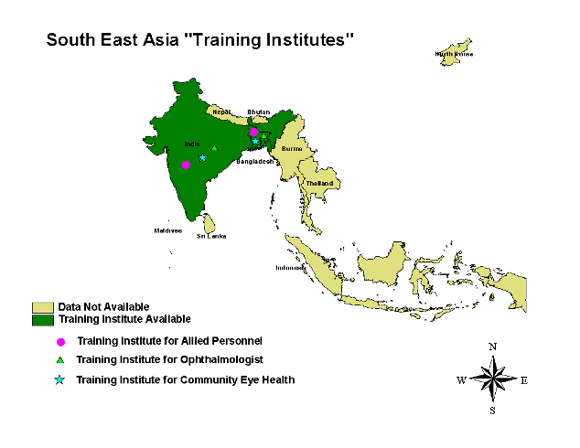

**Training institutes for allied personnel**

**Training institutes for ophthalmologists**

**Training institutes for Community Eye Health**

**Data not available**

**Training Institute Available**

Map 19 Training Institutes in WPR

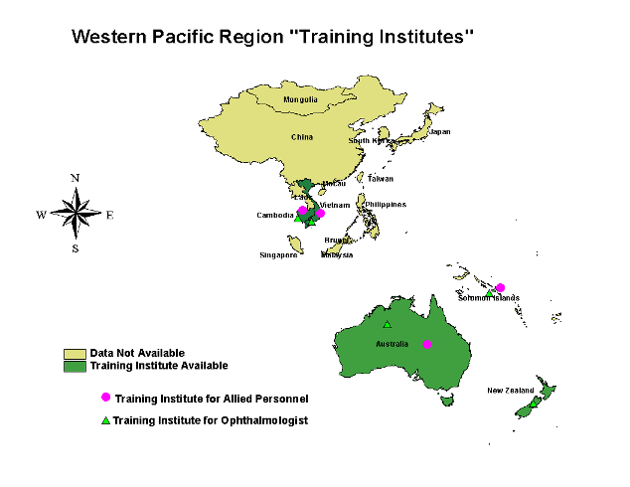

**Training institutes for allied personnel**

**Training institutes for ophthalmologists**

**Data not available**

**Training Institute Available**

empty

# 5. Limitations of the study

**__________________________________________________________________________________**

The crucial importance of human resource in any health care provision system can not be denied, a fact known by almost every body but appreciated by only a few. We have been advocating the role of eye care teams in the vision 2020 framework for almost 8 years, but we still have a lot of mileage to cover. During the situation analysis we have found it extremely difficult to collect valid and updated information from even the developed countries. In fact in the developed countries there was the additional problem of a lot of web- based conflicting information. However we hope to have sensitized at least the participants of the study in maintaining updated information on HR in their own regions or countries.

All public health planning aspects concerning HR need to be based on such updates scientific information and not mere estimation and conjecture. As regards the present study we recognize the limited information especially regarding training institutes that we could present with in the planned time framework, but as we are still receiving data and we hope to regularly upgrade the information on HR in eye care and present it as regular update for circulation among all stake holders of eye care globally and regionally.

# 6. Recommendations

**______________________________________________________________________________________**

1. A workshop may be carried out to establish Global definitions for different cadres of HR working in eye care. These definitions may be linked to levels of skills and/or qualifications achieved by the personnel.
2. Every country must then endeavor as a part of the National programme to collect disaggregated data on available cadres of human resource, preferably upto the level of a district.
3. A gap analysis at country level needs to be undertaken to know the exact country requirements and the areas of need in a country.
4. Based on the above findings a country-based strategic plan for human resource development needs to be undertaken as a part of the National programme for comprehensive eye care and in countries where the plan is already there HRD component needs to be addressed with a focus on situation analysis.
5. The data from the countries needs then to be collated at the regional level and then at the global level.
6. Data on Institutions involved in training and certifying different cadres of eye care workers need to be collected on country level and then collated at regional and global levels.
7. To undertake this very important task it is recommended that National Human Resource Development Task Forces may be developed with specific terms of reference to include, situation analysis, formulation of a strategic plan, implementation, monitoring and evaluation.
8. Regional information resource centers networked with similar country-based units/ centers need to be developed for HMIS in eye care. The issue may be dealt with in the framework of vision 2020 programmes as vision 2020 regional and local resource centers for information capable of regular updating and circulation of information.

# 7. Annexes

## Annex 1: Templates

**____________________________________________________________________________________**

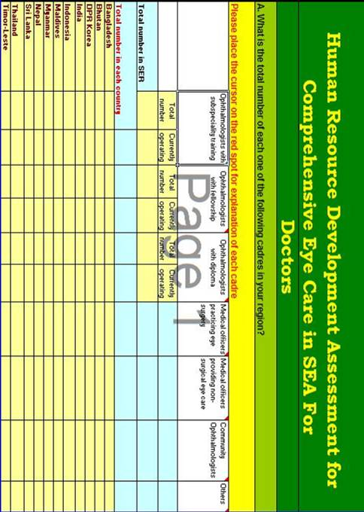



**Training Institutes in *SEA* and courses they offer for Ophthalmologist/Community Ophthalmologist**

**(Short courses\diploma\fellowship\post fellowship)**

|  |  |  |  |  |  |  |  |  |  |  |
| --- | --- | --- | --- | --- | --- | --- | --- | --- | --- | --- |
| **No** | **Name of the institution** | **City/country** | **Contact persons & their Email address** | **Courses**  **offered** | **Offered since** | **Duration of the course** | **Number of students admitted to program per year** | **Number of graduates to date.** | **Certification authority Institute\College\University or any other equivalent body{ please Specify }** | **Accreditation authority University\ council\Board or any other equivalent authority{ please Specify }** |
| 1 |  |  |  |  |  |  |  |  |  |  |
| 2 |  |  |  |  |  |  |  |  |  |  |
| 3 |  |  |  |  |  |  |  |  |  |  |
| 4 |  |  |  |  |  |  |  |  |  |  |

**Training Institutes in SEA and courses they offer for Ophthalmologist/Community Ophthalmologist**

**(Short courses\diploma\fellowship\post fellowship)**

(Ophthalmic assistants, ophthalmic technicians, Ophthalmic nurses, Refractionists, Optometrists, Orthoptists, Ophthalmic technologists, opticians, Low vision specialists, Orientationand mobility trainers, Cataract surgeon and Eye care managers)

**(Short courses\diploma\Bachelors\Masters\Ph.D\fellowship\post fellowship)**

|  |  |  |  |  |  |  |  |  |  |  |
| --- | --- | --- | --- | --- | --- | --- | --- | --- | --- | --- |
| **No** | **Name of the institution** | **City/ country** | **Contact persons & Email address** | **Courses**  **offered** | **Offered since** | **Duration of the course** | **Number of students admitted to program per year** | **Number of graduates to date.** | **Certification authority Institute\College\University or any other equivalent body{ please Specify }** | **Accreditation authority University\ council\Board or any other equivalent authority{ please Specify }** |
| 1 |  |  |  |  |  |  |  |  |  |  |
| 2 |  |  |  |  |  |  |  |  |  |  |
| 3 |  |  |  |  |  |  |  |  |  |  |
| 4 |  |  |  |  |  |  |  |  |  |  |

## Annex 2: Key to the templates

**____________________________________________________________________________________**

|  |  |
| --- | --- |
| **DOCTORS** | **EXPLANATION** |
| Ophthalmologists who are sub-specialists | Ophthalmologists with a minimum of 6 months sub- specialty training after fellowship/residency in ophthalmology accredited by recognized body/institution/council/college. |
| Ophthalmologists with fellowship | Ophthalmologists with a minimum of 3-year post graduate training in ophthalmology accredited by a recognized body/council/college. |
| Ophthalmologists with diploma | Ophthalmologists with a minimum of 1-year postgraduate training in ophthalmology recognized by an accredited college/council/body. |
| Medical officers practicing eye surgery | Doctors with M.B.B.S/M.D who do not have a post graduate qualification (fellowship/residency or diploma) but are practicing surgery in the form of cataract, lid surgery etc. |
| Medical officers providing non-surgical eye care | Doctors with MBBS/MD who do not have a postgraduate qualification (fellowship/residency or diploma) in ophthalmology but are providing non-surgical eye care. |
| Community Ophthalmologists | Doctors with a minimum of 1-year postgraduate training in community ophthalmology accredited by a recognized institute/council/body. |

|  |  |
| --- | --- |
| **cadre** | **EXPLANATION:** |
| **Ophthalmic assistant/technician** | Allied person with a minimum of 1 year training in eye care after ten years of schooling. |
| **Ophthalmic nurses** | Qualified nurses with a minimum of 1 year training in eye care. |
| **Refractionists** | Allied personnel with a minimum of 1 year training in refraction in addition to ophthalmic assistant or ophthalmic technician course. |
| **Biomedical technicians** | Personnel trained in maintenance of equipments. |
| **Optometrists** | Personnel with Bachelors in optometry (minimum of 3 years of training). |
| **Orthoptists** | Allied personnel with BSc or diploma in orthoptics. |
| **Ophthalmic technologist** | Qualified optometrists with a minimum of 1 year training in ophthalmic technology. |
| **Qualified opticians** | Allied personnel with a minimum of 1 year training in dispensing Optics. |
| **Nonqualified practicing opticians** | Allied personnel practicing dispensing of spectacles without any accredited qualifications in dispensing optics. |
| **Low vision specialists** | Ophthalmic allied personnel providing low vision assessments and devices. |
| **Orientation and mobility trainers** | Ophthalmic allied personnel or non-eye care allied personnel providing orientation and mobility training. |
| **Cataract surgeons** | Eye care workers who are not doctors but practicing cataract surgery |
| **Primary eye care workers** | Existing primary health care workers trained in eye care |
| **Eye care managers** | Non – medical personnel providing eye care management |
| **Others** | Allied personnel who do not fall in any of the above mentioned categories. Please specify their cadres, type and duration of training. |

## Annex 3: List of resource personnel

**________________________________________________________________________________**

**1.AFRICA**

Dr. Danial Etayale

Vision2020 Coordinator

WHO prevention of blindness and deafness

Office 6014

CH_1211

Geneva 27 Switzerland.

[etyaaled@yahoo.com](mailto:etyaaled@yahoo.com)

Dr. Boly Olowu

National Coordinator, Nigeria.

[bolaolowu2004@yahoo.com](mailto:bolaolowu2004@yahoo.com)

Dr. Lamine Traoré

Responsible du department de Recherche IOTA, BP 248 .

IOTA,Mali..

[traorel@hotmail.com](mailto:traorel@hotmail.com)

Mr. Tsegaye Bedane Fulassa

Expert coordinator

Federal ministry of health prevention of blindness

Nigeria.

[betsegaye@yahoo.com](mailto:betsegaye@yahoo.com)

Dr. Gracee.B.Saguti

National eye care, Onchocerciasis Program Coordinator

Ministry of health

Tanzania.

[gracejengo@yahoo.co.uk](mailto:gracejengo@yahoo.co.uk)

Dr. Yolanda Zambujo

Coordinator National Prevention Of Blindness

Mozambique.

[Pereira@mail.tropical.co.mz](mailto:Pereira@mail.tropical.co.mz)

**2.AMERICAS**

Dr. Martin Ruppenthal

CBM ,LARO

[martin.ruppenthal@cbm-laro.org](mailto:martin.ruppenthal@cbm-laro.org)

Dr. Rainald Duerksen

Chair IAPB

Dr. Van Lansingh

CBM Co worker

V2020 LAS Regional Coordinator.

[vlansingh@v2020la.org](mailto:vlansingh@v2020la.org)

**3.EMR**

**Mr. Mohammed Ashraf**

 Administrative Assistant

 EMR Office

[mashraf@emr-iapb.org](mailto:mashraf@emr-iapb.org)

Dr. Abdul Hannan Choudhury

Medical Officer,

Control and Prevention of Blindness,

WHO, EMRO , Post Box 7608 Nasr City ,

Cairo11371, Egypt

[choudhurya@emro.who.int](mailto:choudhurya@emro.who.int)

Dr. Abdullah Al Kuhlany

National Coordinator

Prevention Of Blindness Program

Yemen.

[dr_kuhlany@hotmail.com](mailto:dr_kuhlany@hotmail.com)

Dr. Noureddine Chaouki

Director of epidemiology and disease control/focal point

Ministry of health

Morocco

[nchaouki@sante.gov.ma](mailto:nchaouki@sante.gov.ma)

Mr. Mohammad Daher Hassan

Optometrist

General Peltier Hospital

Djibouti.

[hamdi71@hotmail.com](mailto:hamdi71@hotmail.com)

Prof. Asad Aslam Khan

National Coordinator, NCPB

Pakistan

Prof. Mohammad Naseem Panezai

Provincial Coordinator

CEC cell

Balochistan

Pakistan.

Prof. Zia Uddin Ahmed Sheikh

Provincial Coordinator

CEC Cell

Karachi

Sindh

Pakistan.

[ziashaikh@hotmail.com](mailto:ziashaikh@hotmail.com)

Prof .Shad Mohammad

Provincial Coordinator

CEC Cell

Peshawar,

NWFP

Pakistan.

**4.WPR**

Dr. Do Seiha

National PBL and VISION 2020 Coordinator,

Cambodia.

[campbl@online.com.kh](mailto:campbl@online.com.kh)

Dr. Richard Le Mesurier

Vision2020 Regional Coordinator

Western Pacific Region

Centre For Eye Research Australia

[riklem@mac.com](mailto:riklem@mac.com)

University Of Melbourne

Locked Bag8,32 Gisborne Street

East Melbourne Victoria8002

Australia.

Mr .Mike Davies.

Coordinator, CBR Advisory Working Group, CBM.

[mike.davies@cbmseapro.org](mailto:mike.davies@cbmseapro.org)

Dr. Ailian Hu

Secretory Prevention Of Blindness

National Guiding Committee Of Blindness Prevention(NGCBP)

Beijing

China.

[halzx@yahoo.com.cn](mailto:halzx@yahoo.com.cn)

Dr. Quingjunlu

Tongren Hospital

WHO Calloborating Center For Prevention Of Blindness

Beijing

China.

Dr. K. Konayama MD

Department Of Ophthalmology

Juntendo University School Of Medicine,NO 570_78

MizunoSayama,Saitama,

Japan.

[juntenop@iris.dti.ne.jp](mailto:juntenop@iris.dti.ne.jp)

Dr. Noel Chua,

Co-chair IAPB, WPR

Philippines

Diana T. Ureta  
Programme Officer  
CBM International   
Southeast Asia and Pacific Regional Office  
Unit 604, Alabang Business Tower  
1216 Acasia Avenue, Madrigal Business Park  
Alabang, Muntinlupa City 1780  
Philippines

[diana.ureta@cbmseapro.org](mailto:diana.ureta@cbmseapro.org)

Ms. Mavis Campos,

Programme Manager (CBM Co-worker)

Cataract Foundation Philippines, Inc.

 # 9 Medical Lane, 21 St. Extension Capitol Subdivision

 6100 Bacolod City

[cataract@pldtdsl.net](mailto:cataract@pldtdsl.net), [mcampos@pldtdsl.net](mailto:mcampos@pldtdsl.net)

Dr. Evangeline Santos,

 Ophthalmologist/Programme Manager

 Modified Residency Training Programme

  c/o Institute of Ophthalmology,

UP-PGH Compound, Taft Avenue

 Manila, Philippines

[evaliit@hotmail.com](mailto:evaliit@hotmail.com)

Ms. Talica Ratulevu

Vision 2020 Fiji Manager

P.O. Box 4406

Samabula

Suva, FIJI

[vision2020fiji@connect.com.fj](mailto:vision2020fiji@connect.com.fj)

**5.SEA**

Mr. P Kirubanithi

Sr Librarian and Info Officer_ LAICO

Aravind Eye Care System

1,Anna Nagar,Madurai 62 020

Tamil Nadu

India.

Dr. Farida Sirlan

Director Cicendo Eye Hospital

Bandung

Indonesia.

[cehindo@cbn.net.id](mailto:cehindo@cbn.net.id)

Dr. Jose

Deputy Director General

Directorate General Health Services

New Delhi

India

[ddgo@nb.nic.in](mailto:ddgo@nb.nic.in)

Dr. Rabi Ul Hassan

Regional Chairman IAPB SEA

Chittagong

Bangladesh.

[icoceitc@spnetctg.com](mailto:icoceitc@spnetctg.com)

**6.EUROPE:**

Dr. Ivo Kocur

Vision2020,Global Coordinator

WHO,Prevention of Blindness And Deafness

Geneva Switzerland.

[kocuri@who.int](mailto:kocuri@who.int)

Prof Dr. Yury May Chuk

Helmholtz Institute Of Ophthalmology

Moscow

Russian federation.

[VIRUS@igb.ru](mailto:VIRUS@igb.ru)

Dr. Naira Khachtryan,MD,MPH,DRPH candidate

Meghrigian Eye Institute Of Preventive Ophthalmology

Lecturer Of Preventive Ophthalmology

College Of Health Sciences

American University Of Armenia.

[Naira.Khachatryan@lshtm.ac.uk](mailto:Naira.Khachatryan@lshtm.ac.uk)

## Annex 4: Vision 2020 directory of courses

**_________________________________________________________________________________**



**VISION 2020: The Right to Sight**



**(Not including regular degree programmes and residency training programmes)**

Published by

**International Agency for the Prevention of Blindness**

**A SPECIAL SUPPLEMENT FOR TRAINING PROGRAMMES**

Every year a detailed list of VISION 2020-related training programmes is published in the January issue of IAPB News. This includes on-going programmes open to all cadres of eye care professionals from around the world. Starting this year, the schedule of training programmes will be published as a separate supplement and circulated along with January issue. In subsequent years, only updates and changes in existing programmes will be carried in the January issue. A new supplement will be published once in three years unless major changes necessitate earlier publication. This list will not include regular degree and residency programmes. Only those courses open to participants from other countries will be listed.

Updates and details of new programmes must be submitted in the following format.

**Information on Long / Short Term on-going Training Programmes**

Name of the Programme :  
Venue :  
Number of Positions :  
Duration of Programme :  
Contact Information :

(Persons to contact, address & contact numbers, email/website)

This information should reach the following address before 15 December for inclusion in the January issue.

International Agency for the Prevention of Blindness  
IAPB Central Office

1. *L.V. Prasad Eye Institute,*
2. *L.V. Prasad Marg, Banjara Hills*

Hyderabad 500 034, INDIA Fax: +91-40-2354 8271 Email: agency@lvpei.org

Ophthalmology AFRICA

|  |  |  |  |  |
| --- | --- | --- | --- | --- |
| **Location & Institution** | **Name of the Programme** | **Duration** | **No. of Positions** | **Contact** |
| ***Kinshasa, Democratic*** |  |  |  |  |
| ***Republic of Congo*** |  |  |  |  |
| Ophthalmic Training Centre for Central Africa (CFOAC) | Cataract Surgeons Course | 12 Months | 5 | Dr. Adrian Hopkins or Dr. Makwanga Mankiew CFOAC, Bureau de Coordination de la CBM B.P. 406, Kinshasa 1 |
|  |  |  |  | Republique Democratique Du Congo |
|  |  |  |  | Tel / Fax: +243-8803940 / Email: KINCBM@ic.cd *(Note: Training offered to French speaking* |
|  |  |  |  | *candidates from Central Africa)* |
| ***Accra, Ghana*** |  |  |  |  |
| Western African College | Diploma in Ophthalmology | 2 years |  | Ms. Maria Hagan |
|  |  |  |  | email: hagan_maria@yahoo.co.uk |
|  | Fellowship in Ophthalmology | 4 - 5 years |  |  |
| ***Lilongwe, Malawi*** |  |  |  |  |
| SADC Ophthalmic Training | Cataract Surgery Training Prog. | 12 Months | 3 | Professor Mosses C. Chirambo MD, |
| Programme, Malawi College |  |  |  | Course Director |
| of Health Sciences | Diploma in Ophthalmology | 12 Months | - | SADC Ophthalmic Training Centre |
|  | Ophthalmic Clinical Officer | 12 Months | 15 | Malawi College of Health Sciences, Lilongwe. Email: mchirambo@malawi.net |
| ***Pietermartizburg, South Africa*** |  |  |  |  |
| Edendale Hospital | Diploma in Clinical Ophthalmology | 6 Months | 2 | Dr. Colin Cook |
|  |  |  |  | Kwazulu-Natal Blindness Prevention Programme, |
|  |  |  |  | P.O. Box 899, Hilton, 3245 South Africa |
|  |  |  |  | Email: myrna@mweb.co.za |
| ***Moshi, Tanzania*** |  |  |  |  |
| KCMC, Tumaini University ***Dar Es Salaam, Tanzania*** | Assistant Medical Officer in Ophthal­mology and Cataract Surgery | 2 years | 4 | Dr. A.Hall, Principal Assistant Medical Officer in Ophthalmology School, P.O.Box 545, Moshi, Tanzania Tel/Fax: +255 27 2754890 Email: eyedept@kcmc.ac.tz |
| Muhimbili University College | Master of Medicine Ophthalmology | 3 years | 3 | Dr. Dinah Masesa |
| of Health Sciences |  |  |  | Muhimbili University College of Health Sciences Dar Es Salaam, Tanzania Email: masesad@yahoo.com |

Ophthalmology AFRICA

|  |  |  |  |  |
| --- | --- | --- | --- | --- |
| **Location & Institution** | **Name of the Programme** | **Duration** | **No. of Positions** | **Contact** |
| ***Nairobi, Kenya*** |  |  |  |  |
| KMTC | Higher diploma in ophthalmology | 18 months | 10 | The Director, |
|  | & cataract surgery |  |  | KMTC, PO Box 31095, Nairobi, 00100, Kenya |
|  |  |  |  | Email: inquiries@kmtc.ac.ke or |
|  | Higher diploma in cataract surgery | 12 months | 6 | admissions@kmtc.ac.ke |
| ***Addis Ababa, Ethiopia*** |  |  |  | Head, Department of Ophthalmology |
| Addis Ababa University | Diploma in Ophthalmology | 2 years |  | Addis Ababa University, Medical Faculty, |
|  |  |  |  | P.O.Box 9086, Ethiopia |
|  |  |  |  | Email: aauoph@ethionet.et |

LATIN AMERICA

|  |  |  |  |  |
| --- | --- | --- | --- | --- |
| **Location & Institution** | **Name of the Programme** | **Duration** | **No. of Positions** | **Contact** |
| ***Santo Domingo,*** |  |  |  |  |
| ***Dominican Republic*** |  |  |  |  |
| Hospital Dr. Elias Santana | Fellowship Programmes Glaucoma Pediatric Ophthalmology Retina | 1 year 1 year 1 year |  | Dr. Juan Batlle, Professor and Chairman Fantino Falco No. 5, Santo Domingo Dominican Republic Tel: +1-809-563-1324 / Fax: +1-809-544-1885 Email: jbatlle@codetel.net.do |
|  | Oculoplastics Cornea | 1 year 1 year |  | Ms. Nicole Hunter, Administrator Tel: +1-809-545-3348 / Fax: +1-809-545-3329 Email: nicole.hunter@mmint.org |
| ***Asuncion, Paraguay*** |  |  |  | Ms. Evelys Diaz, Academic Coordinator Email: e.diaz@mmint.org |
| Fundacion-Vision | Programa Vision | 3 years | 3 | Dr. Van Lansingh Centro De Microcirugia Y laser AVDA. Rep. Argentina 1383 C/Facundo Machain, Barrio Los Laureles, 1860 Asunsion, Paraguay Tel/Fax: +595 21 615482 Email: residencia@fundacion-vision.org.py www.foundacion-vision.org.py |

Ophthalmology NORTH AMERICA

|  |  |  |  |  |
| --- | --- | --- | --- | --- |
| **Location & Institution** | **Name of the Programme** | **Duration** | **No. of Positions** | **Contact** |
| ***Baltimore, USA*** |  |  |  |  |
| Dana Center for Preventive | Preventive Ophthalmology | 1 year or more | 1 or more | Harry Quigley |
| Ophthalmology | Fellowship |  |  | Johns Hopkins University |
|  |  |  |  | Schools of Medicine and Public Health, |
|  | Public Health Ophthalmology | 1 year | upto 10 | Baltimore MD, USA |
|  | Fellowship |  |  | e-mail: hquigley@jhmi.edu |

EASTERN MEDITERRANEAN

|  |  |  |  |  |
| --- | --- | --- | --- | --- |
| **Location & Institution** | **Name of the Programme** | **Duration** | **No. of Positions** | **Contact** |
| ***Peshawar, Pakistan*** |  |  |  |  |
| Pakistan Institute of Community Ophthalmology | Microsurgical Training Course | 2 weeks | 24 / year | Dr. Mohammad Babar Qureshi Director Academics |
|  |  |  |  | Pakistan Institute of Community Ophthalmology |
|  |  |  |  | Hayatabad Medical Complex |
|  |  |  |  | P.O Box 125, GPO, Peshawar, Pakistan |
|  |  |  |  | Tel: +92-91-9217376 - 80 / 9217425 |
|  |  |  |  | Fax: +92-91-9217413 |
| ***Peshawar, Pakistan*** |  |  |  | Email: pico@pes.comsats.net.pk |
| Khyber Institute of Ophthalmic Medical Sciences | Diploma in Clinical Ophthalmology | 2 years | 9 | Dr. Tariq Babar Clinical Courses Coordinator |
|  | Fellowship in Clinical Ophthalmology | 4 years | upto 10 | Khyber Institute of Ophthalmic Medical Sciences Hayatabad Medical Complex, |
|  |  |  |  | Peshawar, Pakistan |
|  |  |  |  | Tel: +92-91-9217376 - 80 / 819149 |
|  |  |  |  | Fax: +92-91-9217413 |
|  |  |  |  | Email: pico@pes.comsats.net.pk |
| ***Rawalpindi, Pakistan*** |  |  |  |  |
| Al-Shifa Trust Eye Hospital Community Ophthalmology | Fellowship in Ophthalmology Diploma in Ophthalmology Subspeciality Fellowships in Paediatric Ophthalmology | 4 years 2 years 1year | 10 5 2 | Prof. Jahangir Akhtar Dean, Pakistan Institute of Ophthalmology, Al-Shifa Trust Eye Hospital,Jhelum Road, Rawlapindi, Pakistan Tel: 092 51 5487820-24, Fax: 092 51 5487827 |
|  | Subspecialty Fellowships in Medical and Surgical Retina | 1 year | 1 | Email info@alshifa-eye.org.pk |

Ophthalmology EUROPE

|  |  |  |  |  |
| --- | --- | --- | --- | --- |
| **Location & Institution** | **Name of the Programme** | **Duration** | **No. of Positions** | **Contact** |
| ***Sofia, Bulgaria*** |  |  |  |  |
| St. Anna University Hospital | Uveitis / Intraocular Inflammation Herpetic Eye Disease Pseudoexfoliation Syndrome | 5 days 5 days 5 days | 15 15 15 | St. Anna University Hospital, Eye Clinic, 1 Dimitar Mollov Street, 1709 Sofia, Bulgaria. Tel: +35929756023 |
|  | Lasers in Ophthalmologic Practice | 5 days | 15 | Email: centersight@bitex.com |
|  | Keratoplasty | 5 days | 15 |  |
|  | Ocular plastic surgery | 5 days | 15 |  |

SOUTH EAST ASIA

|  |  |  |  |  |
| --- | --- | --- | --- | --- |
| **Location & Institution** | **Name of the Programme** | **Duration** | **No. of Positions** | **Contact** |
| ***Chittagong, Bangladesh*** |  |  |  |  |
| Chittagong Eye Infirmary | Microsurgical & IOL Training | 3 months | 2 | Dr. Munirujzaman Osmani |
| and Training Complex | Glaucoma Cornea | 6 months 3 months | 2 2 | Chittagong Eye Infirmary and Training Complex Pahartali ,P.O. Box: 729, Chittagong-4000, Bangladesh Tel: 659017-19 |
|  | Vitreo Retina | 6 months | 2 | Fax: 880-31-659020 |
|  |  | (Medical) 1 year | 2 | E-mail: icoceitc@spnetctg.com Wed Site: www.eyeinfirmary.org |
|  |  | (Surgical) |  |  |
|  | Paediatric Ophthalmology Fellowship | 6 months | 2 |  |
| ***Guwahati, India*** |  |  |  |  |
| Sri Sankaradeva Nethralaya | Fellowship in General Ophthalmology Fellowship in Vitreo-Retina Surgery Observership in Ophthalmology | 1 year 2 years 3 weeks | 6 2 20 | Dr. Harsha Bhattacharjee Medical Director and Trustee-Sri Sankaradeva Nethralaya, Beltola , Guwahati-781 028 Assam, India Tel: +91-361-2228879/80, 2228921/22, 2305516 Fax: +91-361-2228878 |
|  |  |  |  | Email: ssnghy1@sify.com |

Ophthalmology SOUTH EAST ASIA

|  |  |  |  |  |
| --- | --- | --- | --- | --- |
| **Location & Institution *Hyderabad, India*** L.V.Prasad Eye Institute | **Name of the Programme Long Term Fellowships** Cornea Glaucoma Retina Paediatric Ophthalmic Plastic Surgery Comprehensive ophthalmology **Short term Fellowships** Cornea Glaucoma Retina Pediatric Microsurgery (SICS) Phacoemulsification Retina Laser Ophthalmic Plastic Surgery Ophthalmic Diagnostic Techniques - Basic - Advanced **Observerships** Subspecialty Observership Rotatory Observership (for P.Gs and Residents) | **Duration** 15 months 15 months 15 months 15 months 15 months 3 years 3 months 3 months 3 months 3 months 2 months 1 month 1 month 3 months 1 month 15 days 1 week 1 month | **No. of Positions** 3 1 1 1 1 4 1 1 1 1 1 1 1 1 8 3 1/week 2/month | **Contact** Education Centre L.V.Prasad Eye Institute L.V. Prasad Marg, Banjara Hills Hyderabad 500 034, India Tel: +91-40-306 12 634/ Fax: +91-40-2354 8271 Email: education@lvpei.org Website: www.lvpei.org |

Ophthalmology SOUTH EAST ASIA

|  |  |  |  |
| --- | --- | --- | --- |
| **Location & Institution *Madurai, India*** Aravind Eye Hospital (AEH)/ Lions Aravind Institute of Community Ophthalmology (LAICO) | **Name of the Programme Duration Long-term Ophthalmology Fellowships** Retina-Vitreous 2 years Cornea 18 months Paediatric Ophthalmology and Strabismus 18 months Glaucoma 2 years Anterior segment / Intraocular Lens Microsurgery 2 years Uvea 18 months Orbit and Oculoplasty 18 months **Short-term Ophthalmology Fellowships** Paediatric Ophthalmology 6 months (only for International) (Jan & Jul) **Short Term Clinical Courses** IOL Microsurgery Course 1 month Small Incision Cataract Surgery 1 month Phacoemulsification 1 month Diagnosis and Management 8 weeks of Glaucoma Lasers in Diabetic Retinopathy 2 months Management | **No. of Positions** 8 4 5 5 10 1 2 1 6 6 6 4 4 | **Contact** Dr. Venkatesh Prajna Chief-Department of Medical Education LAICO, 72, Kuruvikaran Salai, Gandhi Nagar Madurai- 625 020, Tamil Nadu, India Tel: +91-452-5356100, Extn: 120 Fax:+91-452-2530984 Email: prajna@aravind.org Dr. P. Vijayalakshmi Chief – Paediatric Ophthalmology Aravind Eye Hospital 1, Annanagar, Madurai - 625020, Tamilnadu, India Tel: 91 452 5356100; Fax: 91 452 2530984 Email: childreneye@aravind.org The IOL-Course Coordinator LAICO, 72, Kuruvikaran Salai, Gandhi Nagar Madurai- 625 020, Tamil Nadu, India Tel: +91-452-5356100, Extn: 120 Fax:+91-452-2530984 Email: training@aravind.org Glaucoma-Coordinator Aravind Eye Hospital, Swamy Nelliappar High Road Tirunelveli, Tamilnadu, India Tel: +91-462-233-7103/04 Fax: +91-462-233-1633 Email: glaucoma@tvl.aravind.org Course-Coordinator Aravind Eye Hospintal – Retina Clinic 1, Annanagar, Madurai – 625 020 Tel: +91-452-5356100, Extn: 115 Fax: +91-452-2530984 Email: uma@aravind.org |

Ophthalmology SOUTH EAST ASIA

|  |  |  |  |  |
| --- | --- | --- | --- | --- |
| **Location & Institution *New Delhi, India*** Venu Eye Institute and Research Centre ***Tiruchirapalli, India*** Joseph Eye Hospital ***Vellore, India*** Schell Eye Hospital | **Name of the Programme** Fellowship - General Ophthalmology Vitreo-Retina Fellowship IOL Microsurgical Training Indirect Ophthalmoscopy with Slit Lamp Funduscopy Contact Lens Training SICS Fellowship in Anterior Segment Fellowship in Posterior Segment Microsurgery Training ECCE & IOL Small Incision Cataract Surgery Phacoemulsification IOL Fellowship | **Duration** 1 year 1 year 2 months 1 month 15 days 1 month 1 year 1 year 8 weeks 8 weeks 8 weeks 2 years | **No. of Positions** 2 1 2 1 1 1 4 4 8 4 4 | **Contact** Dr. Jeena Mascarenhas Consultant – CME Department Venu Eye Institute and Research Centre 1/31, Sheikh Sarai Institutional Area Phase – 2, New Delhi – 110 017 Tel: +91-11-2925 1951 / 2925 0757 / 2925 2417 Fax: +91-11-2925 2370 Email: vcs@spectranet.com (* Open to International Trainees) Dr. Nelson Jesudasan Director, Joseph Eye Hospital Institute of Ophthalmology, P.B.No. 138 Tiruchirapalli 621 001, India Tel: +91-431-2460622 / 2462862 Fax: +91-431-2415922 Email: jehtry@eth.net Dr. Renu Raja Department of Ophthalmology, Schell Eye Hospital Christian Medical College & Hospital Arni Road, Vellore 632 001, Tamilnadu. Tel: +91-416-223-2021 / 222 - 2115 Fax: +91-416-223-2035 |

Low Vision / Rehabilitation AFRICA

|  |  |  |  |  |
| --- | --- | --- | --- | --- |
| **Location & Institution *Nairobi, Kenya*** Kenya Medical Training Centre Kenya Institute of Special Edcuation ***Ruharo, Uganda*** Ruharo Eye Unit | **Name of the Programme** Higher diploma in vision therapy Diploma in vision support Introduction to Low Vision for eye workers | **Duration** 1 year 1 year 6 weeks | **No. of Positions** 4 12 5 | **Contact** The Director KMTC Box 30195, Nairobi 00100, Kenya Email: inquiries@kmtc.ac.ke or admissions@kmtc.ac.ke Dr Kenneth Kagame Medical Director Ruharo Eye Unit, Uganda Tel: 0485 20502 Email: ruharo@utonline.co.ug |

NORTH AMERICA

|  |  |  |  |  |
| --- | --- | --- | --- | --- |
| **Location & Institution** | **Name of the Programme** | **Duration** | **No. of Positions** | **Contact** |
| ***Mexico City, Mexico*** |  |  |  |  |
| Lighthouse International ***New York, USA*** | Manejo Compresible del Pacinte con Baja Vision |  |  | Cathy Czeto Lighthouse International 111 East 59th Street |
| Lighthouse International | Pediatric Low Vision Care | May 5 – 6 |  | New York, NY 10022 |
|  |  | Nov 10-11 |  | www.lighthouse.org/ce |
| ***Philadelphia, USA*** | Diabetes-related Eye Disease and Low Vision Comprehensive Clinical Low Vision Care/Low Vision Therapy | May 20 June 14-16, Sept 27-29 |  | cczeto@lighthouse.org |
| Lighthouse International ***San Francisco, USA*** | Working with Older Adults Who Are Visually Impaired: A Hands-on Approach | Sept 21 |  |  |
| Lighthouse International | Working with Older Adults Who Are Visually Impaired: A Hands-on Approach | Feb 16 |  |  |

Low Vision / Rehabilitation SOUTH EAST ASIA

|  |  |  |  |  |
| --- | --- | --- | --- | --- |
| **Location & Institution** | **Name of the Programme** | **Duration** | **No. of Positions** | **Contact** |
| ***Coimbatore, India*** |  |  |  |  |
| Sri Ramakrishna Mission Vidyalaya | Community Based Rehabilitation | 1 year |  | Dr. M.N.G. Mani, Hon. Director ICEVI, IHRDC Campus Ramakrishna Mission Vidyalaya Coimbatore - 641 020, |
|  |  |  |  | Tamilnadu, India |
|  |  |  |  | Tel: +91-422-269-7529 / 30 Fax: +91-422-269-2353 |
|  |  |  |  | Email: ihrdc@vsnl.net, sgicevi@vsnl.net |
| ***Madurai, India*** |  |  |  |  |
| Aravind Eye Hospital | Training in Low Vision | 1 month | 1 | Dr. Ilango |
|  |  | (every month) |  | Aravind Eye Hospital Low vision Department |
|  |  |  |  | 1, Annanagar, Madurai – 625 020 |
|  |  |  |  | Ph: 91 452 5356100 Extn: 115 |
|  |  |  |  | Fax: 91-452-2530984 Email: ilango@aravind.org |
| ***New Delhi, India*** |  |  |  |  |
| Venu Eye Institute and Research Centre | Low Vision Assessment Training Course | 10 days | 2 | Dr. Jeena Mascarenhas Consultant – CME Department |
|  |  |  |  | Venu Eye Institute and Research Centre |
|  |  |  |  | 1/31, Sheikh Sarai Institutional Area Phase – 2, |
|  |  |  |  | New Delhi – 110 017 |
|  |  |  |  | Tel: +91-11-2925 1951 / 2925 0757 / 2925 2417 |
|  |  |  |  | Fax: +91-11-2925 2370 |
|  |  |  |  | Email: vcs@spectranet.com |
| ***Hyderabad, India*** |  |  |  |  |
| L.V.Prasad Eye Institute | Orientation Workshop Module on Low Vision Awareness | 3 days | 15 | Dr. Sarfaraz Ali Khan Director, Vision Rehabilitation Centres |
|  | Low Vision Care Fellowship | 3 months | 2 | L.V.Prasad Eye Institute L.V. Prasad Marg, Banjara Hills |
|  |  |  |  | Hyderabad 500 034, India |
|  |  |  |  | Tel: +91-40-2354 8267 / Fax: +91-40-2354 8271 |
|  |  |  |  | Email: sarfarazkhan@lvpei.org |

Community Eye Health AFRICA

|  |  |  |  |  |
| --- | --- | --- | --- | --- |
| **Location & Institution** | **Name of the Programme** | **Duration** | **No. of Positions** | **Contact** |
| ***Banjul, The Gambia*** |  |  |  |  |
| Regional Ophthalmic Training Programme, Royal Victoria Teaching Hospital | Certificate in State Enrolled Nurse/Community Health Ophthalmic Nursing | 9 months | 6 | Courses Administrator Regional Ophthalmic Training Programme Royal Victoria Teaching Hospital Banjul, The Gambia OR |
|  |  |  |  | Courses Administrator |
|  |  |  |  | c/o Sight Savers International P.O.Box 950, Banjul, The Gambia Email: rotp@qanet.gm |
| ***Kaduna, Nigeria*** |  |  |  |  |
| Post-Basic Nursing School | Advanced Diploma in Community Ophthalmic Nursing | 12 months |  | Ms. Grace Ekuma, School of Post Basic Ophthalmic Nursing National Eye Centre, PMB 2267, Kaduna, Nigeria |

EASTERN MEDITERRANEAN

|  |  |  |  |  |
| --- | --- | --- | --- | --- |
| **Location & Institution** | **Name of the Programme** | **Duration** | **No. of Positions** | **Contact** |
| ***Peshawar, Pakistan*** Pakistan Institute of Communitiy Ophthalmology | M.Sc in Community Ophthalmology | 1 year | 15 | Dr. Mohammad Babar Qureshi Director Academics Pakistan Institute of Community Ophthalmology Hayatabad Medical Complex P.O Box 125, GPO, Peshawar, Pakistan Tel: +92-91-9217376 - 80/ 9217425 Fax: +92-91-9217413 Email: pico@pes.comsats.net.pk |

EUROPE

|  |  |  |  |  |
| --- | --- | --- | --- | --- |
| **Location & Institution** | **Name of the Programme** | **Duration** | **No. of Positions** | **Contact** |
| ***Munich, Germany*** University Eye Hospital | Tropical Ophthalmology | - | 30 | **Prof. Dr. Med Volker Klauss** University Eye Hospital, Munich. e-mail: Volker.klauss@med.uni-muenchen.de |

Community Eye Health EUROPE

|  |  |  |  |  |
| --- | --- | --- | --- | --- |
| **Location & Institution *London, UK*** London School of Hygiene and tropical Medicine (LSHTM) | **Name of the Programme** MSc Community Eye Health Diploma Course in Community Eye Health Short Course in Tropical Ophthalmology VISION 2020 short course | **Duration** 1 year/2 years part-time. 14 weeks 3 days 5 days | **No. of Positions** 16 5-10 30 30 | **Contact** Ms. Adrienne Burrough, LSHTM, Keppel Street, WC1E 7HT Tel: 44 20 7958 8316 e-mail: adrienne.burrough@lshtm.ac.uk website: www.iceh.org.uk (or) www.lshtm.ac.uk/courses |

SOUTH EAST ASIA

|  |  |  |  |  |
| --- | --- | --- | --- | --- |
| **Location & Institution** | **Name of the Programme** | **Duration** | **No. of Positions** | **Contact** |
| ***Chittagong, Bangladesh*** |  |  |  |  |
| Chittagong Eye Infirmary & Training Complex | Diploma in Community Ophthalmology | 1 year | 6/year | Dr. Md. Fazlul Huq Director - Institute of Community Ophthalmology P.O. Box 729, Pahartali |
|  |  |  |  | Chittagong-4000, Bangladesh Tel.: +880-31-659017 / 19 Fax: +880-31-659020 Email: icoceitc@spnetctg.com |
| ***Hyderabad, India*** |  |  |  |  |
| ICARE | Short course in |  |  |  |
|  | Tropical Ophthalmology | 3 days | 30 | Dr. B.R.Shamanna & Mr. M. Srinivas Course Convenors, ICARE, |
|  |  |  |  | L.V. Prasad Eye Institute, L.V. Prasad Marg, Banjara Hills, Hyderabad - 34 Andhra Pradesh, India |
| L.V.Prasad Eye Institute | Diplomain Community Eye Health (Full Time) Diploma in Community Eye Health (Modular) Community Eye-care Coordinator Training Programme | 6 months 1-3 weeks 6 months | 12/year 3/Module 4/year | The Course Convenor, ICARE L.V.Prasad Eye Institute Post Bag # 1, Kismatpur B.O Rajendernagar P.O, Hyderabad - 500 030 Tel: +91-40-2401 1243 Fax: +91-40-2401 1293 Email: training@icare.stph.net |

Community Eye Health SOUTH EAST ASIA

|  |  |  |  |  |
| --- | --- | --- | --- | --- |
| **Location & Institution** | **Name of the Programme** | **Duration** | **No. of Positions** | **Contact** |
| ***Madurai, India*** |  |  |  |  |
| Aravind Eye Hospital/ Lions Aravind Institute of Community Ophthalmology | Certificate Course in Community Outreach and Social Marketing of Eye Care Services | 4 weeks | 10-15 | Mr. Keerti Pradhan LAICO-AEH, 72, Kuruvikaran Salai Gandhi Nagar, Madurai- 625 020, Tamil Nadu Tel: +91-452-535-6100 Fax: +91-452-2530984 |
|  |  |  |  | Email: courses@aravind.org |
|  | Certificate Course on Outreach | 8 weeks | 2-3 | Ms. Sheela Devi |
|  | Paediatric Eye Care Services (After completing one month course in general Community Outreach and Social Marketing of Eye Care Services) |  |  | (Address same as above) Email: childreneye@aravind.org |
| ***Tiruchirapalli, India*** |  |  |  |  |
| Joseph Eye Hospital | Fellowship in Community | 1 year | 4 | Dr. Nelson Jesudasan |
|  | Ophthalmology |  |  | Director, Joseph Eye Hospital Institute of Ophthalmology, P.B.No. 138 |
|  |  |  |  | Tiruchirapalli 621 001, India |
|  |  |  |  | Tel: +91-431-2460622 / 2462862 |
|  |  |  |  | Fax: +91-431-2415922 |
|  |  |  |  | Email: jehtry@eth.net |

Mid level Ophthalmic Personnel AFRICA

|  |  |  |  |  |
| --- | --- | --- | --- | --- |
| **Location & Institution** | **Name of the Programme** | **Duration** | **No. of Positions** | **Contact** |
| ***Cameroon*** |  |  |  |  |
| University of Yaoundé I | Ophthalmic Nursing | 2 - 5 years | 4 | Profossor Bengono Généviève Professeur Ebana Mvogo Côme Faculty of Medicine |
|  |  |  |  | University of Yaoundé I, Cameroon |
|  |  |  |  | Tel: 00 237 999 16 81 |
|  |  |  |  | Email: ebanamvogo@yahoo.fr |
| ***Kinshasa, Democratic Republic of Congo*** Ophthalmic Training Centre for Central Africa (CFOAC) | Techniciens Superieur en Ophtalmologie (Ophthalmic medical assistants) | 2 Years | 20/year | Dr. Adrian Hopkins or Dr. Makwanga Mankiew CFOAC, Bureau de Coordination de la CBM B.P. 406, Kinshasa 1 Republique Democratique Du Congo Tel / Fax: +243-8803940 Email: KINCBM@ic.cd |

Mid level Ophthalmic Personnel AFRICA

|  |  |  |  |  |
| --- | --- | --- | --- | --- |
| **Location & Institution** | **Name of the Programme** | **Duration** | **No. of Positions** | **Contact** |
| Health For Peace Initiative, Training Programmes | Advanced Diploma in Surgical Ophthalmic Nursing Diploma in Ophthalmic Nursing | 18 months 12 months |  | Dr. Edith Ackuaku C/o Sight Savers International P.O.Box 950 Banjul, The Gambia Email: emack@quanet.gm |
| ***Accra, Ghana*** |  |  |  |  |
| Ophthalmic Nursing School | Optical Technicians Course | 2 years |  | Ms. Ellen A. Clegg, Course Coordinator |
|  | Ophthalmic Nursing Course Equipment Technicians Maintenance Course | 1 year 6 Weeks |  | Ophthalmic Nursing School Korle Bu Teaching Hospital Accra P.O. Box 77, Korle Bu, Ghana |
| Biomedical Engineering Unit, Ministry of Health | Equipment Technicians Maintenance Course | 6-12 Weeks | 8-16 | Head, Biomedical Engineering Unit (Attention: Mr. John Osei), Ministry of Health Korle-Bu, Accra, Ghana |
| ***Kikuyu, Kenya*** |  |  |  |  |
| PCEA Kikuyu Eye Unit | Ophthalmic Assistants Course Ophthalmic Theatre Course Refraction Training Course Instrument Workshop Technician | 12 weeks 10 weeks 12 weeks 8 weeks | 10 5 / 6 2 6 | Dr. Dharminder S. Walia PCEA Kikuyu Eye Unit P. O. Box 1021, Kikuyu, Kenya Tel: 066 32415 / 32852 Email: kikuyueyeunit@maf.or.ke |
| ***Nairobi, Kenya*** |  |  |  |  |
| Kenya Medical Training Centre | Higher Diploma in Ophthalmic | 12 months | 14 | The Director |
|  | Nursing |  |  | KMTC, PO Box 31095, Nairobi, 00100, Kenya |
|  | Diploma in Clinical Technology | 3 years |  | Email: inquiries@kmtc.ac.ke or admissions@kmtc.ac.ke |
| ***Benin City, Nigeria*** |  |  |  |  |
| Post-Basic Ophthalmic | Diploma in Ophthalmic Nursing | 12 months | 25 | Mrs. Iyabo F. Ogbeide |
| Nursing School |  |  |  | Assistant Director of Nursing |
|  |  |  |  | Post Basic School of Ophthalmic Nursing |
|  |  |  |  | University of Benin Teaching Hospital |
|  |  |  |  | Benin City, Nigeria |
| ***Enugu, Nigeria*** |  |  |  |  |
| Post-Basic Ophthalmic | Diploma in Ophthalmic Nursing | 12 months | 15 | Mrs. G. C. Madubuko |
| Nursing School |  |  |  | Post Basic School of Ophthalmic Nursing |
|  |  |  |  | University of Nigeria Teaching Hospital |
|  |  |  |  | Enugu, Nigeria |

Mid level Ophthalmic Personnel AFRICA

|  |  |  |  |  |
| --- | --- | --- | --- | --- |
| **Location & Institution** | **Name of the Programme** | **Duration** | **No. of Positions** | **Contact** |
| ***Kaduna, Nigeria*** |  |  |  |  |
| National Eye Centre | Ophthalmic Nursing Course | 12 months |  | Sight Savers International |
| School of Post Basic Nursing Ahmadu Bello University Teaching Hospital | Ophthalmic Nursing Course | 12 months |  | P.O.Box 503, Kaduna, Nigeria OR 1 Golf Course Road, Kaduna, Nigeria Email: ssing@infoweb.abs.net / |
| University of Jos | IOL Conversion Course |  |  | sightsavers@wwlkad.com |
| Teaching Hospital |  |  |  |  |
| University College Hospital | IOL Conversion Course |  |  |  |
| Post-Basic Ophthalmic | Diploma in Ophthalmic Nursing | 12 months |  | Ms. Grace Ekuma |
| Nursing School |  |  |  | School of Post Basic Ophthalmic Nursing |
|  |  |  |  | National Eye Centre, Kaduna, Nigeria |
| Post-Basic Nursing School | Diploma in Ophthalmic Nursing | 12 months |  | The Principal, Post Basic School of Nursing |
|  |  |  |  | Ahmadu Bello University Teaching Hospital |
| National Eye Centre | Equipment Technicians | 6-12 weeks | 12-20 | Head, Department of Biomedical Engineering |
|  | Maintenance Course |  |  | National Eye Centre, Kaduna, Nigeria |
|  |  |  |  | Email: neckad@yahoo.com |
| ***Lagos, Nigeria*** |  |  |  |  |
| Post-Basic Ophthalmic | Diploma in Ophthalmic Nursing | 12 months | 15 | Mrs. Kate C. Onuoha |
| Nursing School |  |  |  | Post Basic School of Ophthalmic Nursing |
|  |  |  |  | Lagos University Teaching Hospital, Lagos, Nigeria |
| ***Dakar, Senegal*** |  |  |  |  |
| Hospital Le Dantec | Technicien Superieur de | 2 years | 10 in | Prof. Alassane Wade |
|  | Ophthalmologie | 2 years |  | Chef de Service, Clinique Ophthalmologique |
|  |  |  |  | Hopital Le Dantec, Dakar, Senegal |
| ***Cape Town, South Africa*** |  |  |  |  |
| Cape Technikon | Diploma - Dispensing Optician |  |  | Head of Department- Mr. Peter Clarke-Farr Department Opticianary, P.O. Box 652 Cape Town, South Africa 8000 Tel: +27-21-460 3169/Fax: +27-21-460-3723 Email: pclarke@ctech.ac.za Web Page: www.ctech.ac.za/crses/od.html |

Mid level Ophthalmic Personnel AFRICA

|  |  |  |  |  |
| --- | --- | --- | --- | --- |
| **Location & Institution** | **Name of the Programme** | **Duration** | **No. of Positions** | **Contact** |
| ***Durban, South Africa*** |  |  |  |  |
| International Centre for | Train The Trainer: Refraction | 8 weeks | 10 | Ms. Palesa Dube |
| Eyecare Education (ICEE) | Programme |  |  | Tel: +27-31-2044088/ Fax: +27-31-2044666 |
| University of Durban Westville |  |  |  | Email: palesa@iceeafrica.co.za |
| ***Pietermartizburg, South Africa*** |  |  |  |  |
| Edendale Hospital | KwaZulu-Natal Eye Care Programme | 12 months | 12 | Dr. Colin Cook |
|  | Ophthalmic Nurse Training |  |  | Kwazulu-Natal Blindness Prevention Programme, |
|  |  |  |  | P.O. Box 899, Hilton, 3245 South Africa |
|  |  |  |  | Email: myrna@mweb.co.za |
| ***Moshi, Tanzania*** |  |  |  |  |
| KCMC, Tumaini University | Ophthalmic Nursing | 2 years | 14 | Mr. Zephania Memba, Principal School of Advanced Ophthalmic Nursing P.O.Box 3010, KCMC, Moshi, Tanzania |
|  |  |  |  | Tel: +255-27-2754377 Ext. 416 Fax: 2754381 |
|  |  |  |  | Email: kcmcadmin@kcmc.ac.tz |
| ***Mvumi, Tanzania*** |  |  |  |  |
| Mvumi Mission Hospital | Ophthalmic Medical Assistant | 12 weeks | 12 | Head of Eye Unit |
|  |  |  |  | Mvumi Mission Hospital, Tanzania |
|  | Ophthalmic Medical Assistant - Refresher | 1 week | 12 | Tel: 23 24361 ext 25 Email: mheyedept@yahoo.com |
| ***Lomé, Togo*** |  |  |  |  |
| Faculté de Médecine, | Technicien Supérieur de | 3 years | 4 - 8 | Prof. Patrice Balo |
| Université de Lomé | Ophtalmologie |  |  | Faculté de Médecine, |
|  |  |  |  | Université de Lomé, Lomé, Togo |
|  |  |  |  | Email : komibalo@yahoo.fr |
| ***Mbarara, Uganda*** |  |  |  |  |
| Ruharo Eye Centre | Ophthalmic Assistant Course Theatre Assistant | 3 months 10 weeks | 10 - 12 8 - 10 | Medical Director Ruharo Eye Centre Box 14, Mbarara, Uganda. Tel: +256 48520502 |
|  |  |  |  | Email: ruharo@utlonline.co.ug |

Mid level Ophthalmic Personnel LATIN AMERICA

|  |  |  |  |  |
| --- | --- | --- | --- | --- |
| **Location & Institution** | **Name of the Programme** | **Duration** | **No. of Positions** | **Contact** |
| ***Santo Domingo,*** |  |  |  |  |
| ***Dominican Republic*** |  |  |  |  |
| Hospital Dr. Elias Santana | Ophthalmic Assistant Programme | 2 years |  | Dr. Juan Batlle, Professor and Chairman |
|  |  |  |  | Fantino Falco No. 5, Santo Domingo |
|  |  |  |  | Dominician Republic |
|  |  |  |  | Tel: +1-809-563-1324 / Fax: +1-809-544-1885 |
|  |  |  |  | Email: jbatlle@codetel.net.do |
| ***Quito, Ecuador*** |  |  |  |  |
| Foundation Ophthalmologica | Ophthalmic Assistants Training | 6 months | 4 | Dr. Filipe Chiriboga |
| of Valley |  |  |  | Foundation Ophthalmologica of Valley |
|  | Ophthalmic Nurses Training | 11 months | 2 | P.O. Box 17-22-20287, Quito, Ecuador |
|  |  |  |  | Email: fechifov@interactive.net.ec |

EASTERN MEDITERRANEAN

|  |  |  |  |  |
| --- | --- | --- | --- | --- |
| **Location & Institution** | **Name of the Programme** | **Duration** | **No. of Positions** | **Contact** |
| ***Karachi, Pakistan*** |  |  |  |  |
| Al-Ibrahim Eye Hospital | Ophthalmic Technician | 1 year | 20 | Prof. Saleh Memon Medical Director |
|  |  |  |  | Al-Ibrahim Eye Hospital, Malir, Karachi Tel: + 92-21-4560708 Fax: +92-21-4560718 |
|  |  |  |  | Email: aiehpk@yahoo.com |
| ***Karachi, Pakistan*** |  |  |  |  |
| Prevention and Control | Ophthalmic Technician | 1 year | 20 | Prof. Ziauddin Sheikh |
| of Blindness Cell |  |  |  | Dept. of Ophthalmology Civil Hospital, Karachi |
|  | Refractionist | 2 years | 10 | Tel: + 92-21-7775445 Fax: +92-21-7775445 Email: comeye@cyber.net.pk |
| ***Lahore, Pakistan*** |  |  |  |  |
| Pakistan Institute of Community Ophthalmology | Ophthalmic Technician Refractionist | 1 year 2 years | 20 10 | Prof. Asad Aslam Khan Project Director Punjab Institute of Preventive Ophthalmology, Mayo Hospital, Lahore |
|  |  |  |  | Tel: + 92-42-7355998 Fax: +92-42-7355998 |
|  |  |  |  | Email: drasad@lhr.comsats.net.pk |

Mid level Ophthalmic Personnel EASTERN MEDITERRANEAN

|  |  |  |  |  |
| --- | --- | --- | --- | --- |
| **Location & Institution** | **Name of the Programme** | **Duration** | **No. of Positions** | **Contact** |
| ***Peshawar, Pakistan*** |  |  |  |  |
| Pakistan Institute of Community Ophthalmology | Ophthalmic Technicians course District Refractionist Course | 1 year 3 years | 40 15 | Dr. Khadija Nowaira Abdullah, Director PCVS Pakistan Institute of Community Ophthalmology Hayatabad Medical Complex P.O Box 125, GPO, Peshawar, Pakistan |
|  | Ophthalmic Nurses Course | 1 year | 5 | Tel: +92-91-9217376 - 80 / 9217425 Fax: +92-91-9217413 |
|  |  |  |  | Email: pico@pesh.pico.comsats.pk |
| ***Rawalpindi, Pakistan*** |  |  |  |  |
| Al-Shifa Trust Eye Hospital | Ophthalmic Technicians | 1 year | 15 | Dr. Wajid Ali Khan, |
|  | Ophthalmic Nursing Optometry | 1 year 2 years | 10 12 | Chief Consultant, Associate Dean, National Academy of Paramedics, Al-Shifa Trust Eye Hospital, |
|  | Orthoptics | 1 year | 3 | Jhelum Road, Rawlapindi, Pakistan Tel: 092 51 5487820-24, Fax: 092 51 5487827; |
|  |  |  |  | Email info@alshifa-eye.org.pk |

SOUTH EAST ASIA

|  |  |  |  |  |
| --- | --- | --- | --- | --- |
| **Location & Institution** | **Name of the Programme** | **Duration** | **No. of Positions** | **Contact** |
| ***Chittagong, Bangladesh*** |  |  |  |  |
| Chittagong Eye Infirmary | Long Courses |  |  |  |
| & Training Complex | Ophthalmic Paramedic Certificate Course | 1 year | 12 | Dr. Munirujzaman Osmani Managing Trustee |
|  | Ocular Microbiology & Laboratory | 1 year | 2 | Chittagong Eye Infirmary and Training Complex P.O. Box 729, Pahartali |
|  | Short Courses |  |  | Chittagong-4000, Bangladesh |
|  | Refraction, Low Vision and Contact Lens Orthoptics Operation Theatre | 6 months 6 months 3 months | 8 4 4 | Tel.: +880-31-659017 / 19 Fax: +88-31-659020 Email: icoceitc@spnetctg.com Website: www.eyeinfirmary.com |
|  | Glaucoma | 3 months | 4 |  |
|  | Retina | 3 months | 4 |  |
|  | Ocular Laboratory | 3 months | 4 |  |

Mid level Ophthalmic Personnel SOUTH EAST ASIA

|  |  |  |  |  |
| --- | --- | --- | --- | --- |
| **Location & Institution** | **Name of the Programme** | **Duration** | **No. of Positions** | **Contact** |
| ***Hyderabad, India*** |  |  |  |  |
| L.V.Prasad Eye Institute | Eye Banking Techniques Training (Short term) Eye Banking Techniques and Management (Observership) Grief Counseling | 3 months 1 week 1 month | 12/year 2/month 12/year | Ramayamma International Eye Bank L.V.Prasad Eye Institute L.V. Prasad Marg, Banjara Hills Hyderabad 500 034, India Tel: +91-40-2354 8267 / Fax: +91-40-2354 8271 Email: rieb@lvpei.org / Website: www.lvpei.org |
|  | Ophthalmic Technicians Skills Refinement Programme Bio-medical cum Maintenance Technician Training Programme | 4 months 6 months | 12/year 12/year | ICARE, L.V.Prasad Eye Institute Post Bag # 1, Kismatpur B.O Rajendernagar P.O, Hyderabad - 500 030 Tel: +90-40-2401 1243 Fax: +90-40-2401 1293 |
|  | Patient Counselor Training Programm | e 6 months | 6/year | Email: vilas@icare.stph.net |
|  | Medical Records Assistant | 3 months | 12/year |  |
|  | Training Programme |  |  |  |
|  | Stores Assistant Training Programme | 3 months | 12/year |  |
|  | Optician Training Programme | 6 months | 4/year |  |
| ***Madurai, India*** |  |  |  |  |
| Aravind Eye Hospital/ Lions Aravind Institute of Community Ophthalmology | Long term Courses PG Diploma in Optometry | 2 years (offered once a year, August) | 10 per batch |  |
|  | PG Dip. in Ophthalmic Assistants Short term Courses | 2 years (offered once a year, August) | 10 per batch | Dr. Usha Kim Aravind Eye Hospital 1, Annanagar, Madurai - 625 020, Tamilnadu, India |
|  | Certificate Course for Clinical & Supervisory Skills Development in Ophthalmic Paramedical | 3 months (offered twice a year, April | 8-10 per batch | Ph: 91 452 5356100 Extn: 113 Fax: 91-452-2530984 Email: education@aravind.org |
|  | Personnel | & October) |  |  |
|  | Certificate Course on | 3 months | 7-9 per batch |  |
|  | Optical Dispensing | (July & |  |  |
|  |  | December) |  |  |

Mid level Ophthalmic Personnel SOUTH EAST ASIA

|  |  |  |  |  |
| --- | --- | --- | --- | --- |
| **Location & Institution** | **Name of the Programme** | **Duration** | **No. of Positions** | **Contact** |
| ***Contd.,*** |  |  |  |  |
|  | Training course for Orthoptist | 6 Months Jan & July) | 1-2 per batch | Dr. P. Vijayalakshmi Chief – Paediatric Ophthalmology |
|  | Training course for Paediatric Nurse | 3 months (Jan, Jun & Sept) | 2-4 per batch | Aravind Eye Hospital 1, Annanagar, Madurai - 625 020, Tamilnadu, India |
|  | Training course for Paediatric Counsellors | 3 months (Jan, Jun & Sept) | 1-2 per batch | Ph: 91 452 5356100; Fax: 91 452 2530984 Email: childreneye@aravind.org |
|  | Certificate course in Fundus Fluorescein Angiography and Ultrasonography | 2 months (1st of every month) | 1 per batch | Dr.R.Kim CORE Faculty, TIFAC-CORE in Diabetic Retinopathy |
|  |  |  |  | Aravind Eye Hospital |
|  |  |  |  | 1, Annanagar, Madurai - 625 020, |
|  |  |  |  | Tamilnadu, India |
|  |  |  |  | Ph: 91 452 5356100; |
|  |  |  |  | Fax: 91 452 2530984 |
|  |  |  |  | Email: uma@aravind.org |
|  | Certificate course on | 6 weeks | 6 per batch | Prof. V. Srinivasan |
|  | Instruments Maintenance |  |  | LAICO, 72, Kuruvikaran Salai, Gandhinagar, |
|  | Certificate course on Instruments Maintenance (for Ophthalmologists) | 5 days (upon request) | 5 per batch | Madurai - 625 020, Tamilnadu, India Ph: 91-452-5356100;Extn: 429, Fax: 91-452-2530984 Email: v.srinivasan@aravind.org |
| ***Mumbai, India*** |  |  |  |  |
| Premlila Vithaldas Polytchnic | Diploma in Ophthalmic Techniques | 3 years | 25/year | Ms. Radha Sinha Principal SNDT Women’s University, Santacruz Mumbai - 400 049, India |
|  |  |  |  | Tel: +91-22-660-5126 / 660-8676 Fax: +91-22-660-7668 |
|  |  |  |  | Email: pvpelex@bom3.vsnl.net.in |

Mid level Ophthalmic Personnel SOUTH EAST ASIA

|  |  |  |  |  |
| --- | --- | --- | --- | --- |
| **Location & Institution** | **Name of the Programme** | **Duration** | **No. of Positions** | **Contact** |
| ***New Delhi, India*** |  |  |  |  |
| Venu Eye Institute and | Diploma in Ophthalmic Techniques* | 3 years | 10 | Dr. Jeena Mascarenhas |
| Research Centre | Special Ophthalmic Paramedics Course Advanced ophthalmic Nurses Course Ophthalmic O.T Technicians Training Course Instrument Maintenance Course Contact Lens Training | 8 months 3 months 6 months 6 weeks 15 days | 10 2 4 2 1 | Consultant – CME Department Venu Eye Institute and Research Centre 1/31, Sheikh Sarai Institutional Area, Phase – 2, New Delhi – 110 017 Tel: +91-11-2925 1951 / 2925 0757 / 2925 2417 Fax: +91-11-2925 2370 / Email: vcs@spectranet.com |
|  |  |  |  | (* Open to Indian Nationals only) |
| ***Tiruchirapalli, India*** |  |  |  |  |
| Joseph Eye Hospital | Certificate Course in Ophthalmic Technology Diploma in Ophthalmic Technology | 1 year 2 years | 12 12 | Dr. Nelson Jesudasan - Director Joseph Eye Hospital, Institute of Ophthalmology, P.B.No. 138 Tiruchirapalli 621 001, India |
|  |  |  |  | Tel: +91-431-2460622 / 2462862 Fax: +91-431-2415922 |
|  |  |  |  | Email: jehtry@eth.net |

Eye Care Management Personnel AFRICA

|  |  |  |  |  |
| --- | --- | --- | --- | --- |
| **Location & Institution** | **Name of the Programme** | **Duration** | **No. of Positions** | **Contact** |
| ***Durban, South Africa*** |  |  |  |  |
| Edendale Hospital | Certificate Course in Planning | 10 weeks | 10 | Dr. Colin Cook |
|  | and Management of VISION 2020 |  |  | Kwazulu-Natal Blindness Prevention Programme, |
|  | Programmes |  |  | P.O. Box 899, Hilton, 3245 South Africa |
|  |  |  |  | Email: myrna@mweb.co.za |
| ***Moshi, Tanzania*** |  |  |  |  |
| Kilimanjaro Centre for Community Ophthalmology | Organisational & Financial Management to achieve VISION 2020 in Africa How to use a manager to achieve VISION 2020 in Africa | 2 weeks 1 week | 15 15 | Co-Director Kilimanjaro Centre for Community Ophthalmology Tumaini University / KCMC PO Box 2254, Moshi, Tanzania Tel: +255-27-2753547 Email: pcourtright@kcco.net |
|  | Strategies to “Bridge” Communities and Eye Care Providers to Ahieve VISION 2020 in Africa | 1 week | 15 |  |

EASTERN MEDITERRANEAN

|  |  |  |  |  |
| --- | --- | --- | --- | --- |
| **Location & Institution** | **Name of the Programme** | **Duration** | **No. of Positions** | **Contact** |
| ***Peshawar, Pakistan*** |  |  |  |  |
| Pakistan Institute of Community Ophthalmology | Short Course on Planning in Eye Care Short Course on Communication Skills Short Course on Management in Eye care | 1 week 1 week 1 week | 30 30 30 | Dr. Mohammad Babar Qureshi Director Academics, Pakistan Institute of Community Ophthalmology Hayatabad Medical Complex P.O Box 125, GPO, Peshawar, Pakistan |
|  |  |  |  | Tel: +92-91-9217376 - 80/ 9217425 |
|  |  |  |  | Fax: +92-91-9217413 |
|  |  |  |  | Email: pico@pes.comsats.net.pk |

Eye Care Management Personnel SOUTH EAST ASIA

|  |  |  |  |  |
| --- | --- | --- | --- | --- |
| **Location & Institution** | **Name of the Programme** | **Duration** | **No. of Positions** | **Contact** |
| ***Hyderabad, India*** |  |  |  |  |
| L.V.Prasad Eye Institute | Eye-Care Manager Training Programme | 1 year | 12/year | ICARE, L.V.Prasad Eye Institute Post Bag # 1, Kismatpur B.O Rajendernagar P.O, Hyderabad - 500 030 Tel: +90-40-2401 1243 Fax: +90-40-2401 1293 |
|  |  |  |  | Email: vilas@icare.stph.net |
| ***Madurai, India*** |  |  |  |  |
| Aravind Eye Hospital/ Lions Aravind Institute of Community Ophthalmology | Postgraduate Diploma in Hospital Management | 1 year | 20 | Mr. P. Rajendran LAICO-AEH, 72, Kuruvikaran Salai, Gandhi Nagar, Madurai- 625 020, Tamil Nadu, Tel: +91-452-535-6100 |
|  |  |  |  | Fax: +91-452-253-0984 |
|  |  |  |  | Email: courses@aravind.org |
|  | Management Training & Systems Development for Hospital Administrators / Managers | 6 weeks | 10 | Mr. Suresh Kumar (address same as above) |
|  | Management Training for Eye Care Programme Managers | 2 weeks | 20 | Mr. Keerti Pradhan (address same as above) |
|  | Management Training for Ophthalmic Heads of Eye Hospitals | 1 week | 20 | Ms. G.K. Veni (address same as above) |
|  | Fellowship in Eye Hospital Management | 1 year | 7 | Mr. Sanil Joseph (address same as above) |

**VISION 2020 Calendar of Events for year 2006**

|  |  |  |  |  |
| --- | --- | --- | --- | --- |
| **MONTH** | **DATE** | **PLACE** | **CONTACT PERSONS** | **EVENT** |
| February | 7-8 | Ghana, Accra | ICEH | Stakeholders planning |
|  | Feb 27 - Mar 1 | South Africa,Cape Town | Dr Colin Cook | Registrar CEH training |
|  | Feb 27 | Chad, N’djamena |  | National planning |
|  | - Mar 3 |  |  |  |
| March | 20-24 | Niger |  | National planning |
|  | 20-25 | India, Delhi | G V Murthy | Refractive error – identifying information |
|  |  |  |  | needs for programs, and designing studies |
|  |  |  |  | to address them |
|  | 21-23 | Saudi-Arabia, Riyadh |  | National planning |
|  | 27-31 | Cape Verde, Praia | Odusote | National VISION 2020 Plans for Lusophone countries |
|  |  | Nigeria | Odusote Ebri | Training of Trainers in CEH for Optometrists |
|  |  | Shenyang, | Provincial Health Bureau | Develop VISION 2020 provincial plan |
|  |  | Liaoning Province |  |  |
|  |  | Nicaragua, Managua |  | National planning |
| April | 19-20 | Chengdu, Sichuan Province | Provincial Health Bureau | Develop VISION 2020 provincial plan |
|  | 24-27 | East Africa, Moshi | Dr Paul Courtright | Training of Trainers from Ethiopia, Kenya, |
|  |  |  |  | Mozambique, Tanzania and Uganda for |
|  |  |  |  | District 2020 workshops |
|  |  | Ghana | ICEH | District-level Operational Planning |
|  |  | Malawi, Lilongwe | Dr Moses Chirambo | Malawi, Zambia, Zimbabwe district planning |
| May |  | Uganda, Kampala | Dr Paul Courtright | Review of 1st 5 year VISION 2020 plan |
|  | Mozambique x 2 | Dr Paul Courtright | District planning (2 provinces) |
| 19-12 | Libya - Tripoli |  | National planning |

**Dates to be Announced**

|  |  |  |  |  |
| --- | --- | --- | --- | --- |
| **MONTH** | **DATE** | **PLACE** | **CONTACT PERSONS** | **EVENT** |
|  | 29-31 | Iran, Teheran | Dr Babar Qureshi | National planning |
|  |  | Taiyuan, Shanxi Province | Provincial Health Bureau | Develop VISION 2020 provincial plan |
|  |  | Xining, Qinhai Province | Provincial Health Bureau | Develop VISION 2020 provincial plan |
| June | 25-29 | Czech Rep, Prague | Dr Ivo Kocur | Advocacy for 5 countries |
|  | 27-30 | Madagascar, Antananarivo, | Dr Robson | Madagascar district planning |
|  |  | Kunming, Yunnan Province | Provincial Health Bureau | Develop VISION 2020 provincial plan |
|  |  | South Africa, Cape Town | Dr Kluever | South Africa district planning |
| July | 3-7 | London, LSHTM, | Graham Dyer | Planning VISION 2020 for NGOs |
|  | 24-28 | Angola, Luanda | Brechet | Angola national planning |
|  |  | Togo | Sacko | District-level planning |
|  |  | Urumqi, Xinjiang Uger | Provincial Health Bureau | Develop VISION 2020 provincial plan |
|  |  | Autonomous Region |  |  |
| August | 7-10 | Dubai |  | National planning |
|  | 20-31 | Syria |  | Damascus Sensitization on VISION 2020 |
|  |  | Lanzhou, Gansu Province | Provincial Health Bureau | Develop VISION 2020 |
|  |  |  |  | provincial plan |
| September | 14-16 | Lithuania, Vilnius, |  | Increase awareness of ROP |
|  | 25-29 | Tanzania, Arusha, | Dr Paul Courtright | District planning (2-3 districts) |
|  | 28-29 | Mexico | CBM Mexico | District planning |
|  |  | Tanzania | Dr Paul Courtright | CEH course 8 weeks |
|  |  | Afghanistan, Kabul | Dr Babar Qureshi | Sensitization on VISION 2020 |
|  |  | Bolivia | CBM Quito | National planning |
| October |  | Chile | CBM Quito | Southern countries |
| November |  | Brazil | CBM Quito | District planning |

## Annex 5:Additional information about training courses

**________________________________________________________________________________**

Additional data on training institutes. (As of june2006)

Ophthalmology

EMRO:

|  |  |  |  |  |
| --- | --- | --- | --- | --- |
| **Location & Institution** | **Name of the Programme** | **Duration** | **No. of Positions** | **Contact** |
| **Al-Asema, Kuwait**  Al-Bahar Ophthalmic Centre | Degree in Ophthalmology | 5 years | 3-4 |  |
| **Triploi, Libya**  Triploi Eye Hospital | Diploma in Ophthalmology | 4 years | 93 |  |

SEARO:

|  |  |  |  |  |
| --- | --- | --- | --- | --- |
| **Location & Institution** | **Name of the Programme** | **Duration** | **No. of Positions** | **Contact** |
| **Dhaka, Bangladesh**  MA Isphanani and Islamia Eye Hospital | Diploma in Ophthalmology  Fellowship in Cornea  MSICS Training  IOL Micro Surgery Training | 1 year  8 weeks  4 weeks  10 weeks | 6-7  02  12  16 | Mrs. Zahida Isphanani, Advisor Farm Gate Dhaka [zdee@bangla.net](mailto:zdee@bangla.net) or [ieh@bdcom.com](mailto:ieh@bdcom.com) |
| Dhaka, BSMMU | DO  MSc in Ophthalmology  FCPS (part II) | 1 year  3 years | 05  05  05 | Prof: MD Salehuddin  [Ophthalmology.bsmmu@yahoo.com](mailto:Ophthalmology.bsmmu@yahoo.com) |
| Dhaka, National Institute of Ophthalmology | DO  MSc in Ophthalmology  FCPS (part II)  IOL Micro Surgery Training  PHACO Training | 1 year  3 years  10 weeks  8 weeks | 10-12  05  05  16  06 | Prof: Maruf Ali,  Director Sher-e-Bangla Nagar |
| Dhaka, Dhaka Medical College Hospital | DO  MS in Ophthalmology | 1 year  3 years | 05  05 | Prof: Din Mohammad Noor-ul-Haq |
| Dhaka, Lions Eye Hospital | DO | 1 year | 05 | Prof: Haleem Khan |
| Dhaka, Sir Samiullah Medical College Hospital | MSc in Ophthalmology | 3 years | 05 | Prof: Arif Miah |
| Dhaka, BIRDEM | DO | 1 year | 05 | Prof: M Syed-ur-Rheman |
| Sylhet, Sylhet Osmani Medical College | MSc in Ophthalmology | 3 years | 03 |  |
| Chittagong, Chittagong Medical College Hospital | MSc in Ophthalmology | 3 years | 03 |  |
| Mymensingh, Mymensingh Medical College Hospital | MSc in Ophthalmology | 3 years | 03 |  |
| Rangpur, Rangpur Medical College Hospital | DO | 3 years | 03 |  |
| Barisal, Barisal Medical College Hospital | DO | 3 years | 03 |  |
| Chittagong, Eye Infirmary and Training Complex and Institute of Community Ophthalmology | Diploma in Community Ophthalmology | 2 years | 08 | Prof: Rabiul Husain, MD CEITC, Pahartali icoceitc@spnetctg.com |
|  |  |  |  |  |

**WPR**

|  |  |  |  |  |
| --- | --- | --- | --- | --- |
| **Location & Institution** | **Name Of The programme** | **Duration** | **No. of Positions** | **Contact** |
| Cambodia: |  |  |  |  |
| Takeo Eye Hospital. | Basic Eye Doctor  DO  BEN. | 18 months.  24 months  9 months. | 3  3  8_11 | Caritas/CBM  cariteh@camintel.com |
|  |  |  |  |  |
| COA(Cambodian Optometrist Association)(PhnomPenh) | Nurse.  Refractionist. | 6 months. | 5 | COA/CBM. |
| Kompot Nursing School | Ophthalmic nursing. | 8 months. | 10. | Do Seiha  campbl@online.com.kh |
| Caritad RBC | Orientation and Mobility Trainers. | 2 months. | As requested. |  |
| Takeo Eye Hospital+ Kompot Nursing School | DON. | 11 months | 5 | Caritas/CBM |
| Vietnam: |  |  |  |  |
| VNIO(Ha_Noi-Vietnam) | Ophthalmic Nurses. | 6 months. | 50 | Prof Ton Thi Kim Thanh. |
| Eye Care Hospital Of Ho Chi Minh City. | Ophthalmic nurses.  Refractionist. | 6 months.  6 months. | 50.  40 | Dr Tran Thi Phuong Thu. |
| VNIO and Ha Noi Medical School. | Ph.D Ophthalmology. | 5 years. | 5. | Prof Ton Thi Kim Thanh. |
| Ha noi Medical University. | Msc Ophthalmology.  Ophthalmologist 1st degree.  Ophthalmologist 2nd degree.  Basic Eye Doctor. | 2 years.  2 years.  2 years.  1 year(10 months) | 10.  50  5.  50. | Prof Ton Thi Kim Thanh. |
| Soloman islands: |  |  |  |  |
| PacificEye Institute(Honiara) | Postgraduate Diploma Of Eye care(to nurses mainly)  D.O  Masters-In Ophthalmology | 1 year.  1year.  4 years. | 6-14  2-6  2-6 | Koni Szetu  resorce@pacificeyeinstitute.com.sb |
| Australia and Newzealand. |  |  |  |  |
| RANZCO | VTP Fellowship. | 5 years. | 28 | <ranzco@ranzco.edu> |
| Save Sight Institute.(Sydney) | Diploma  Masters In Basic Sciences. | 1year  3 years. | 2  2 | Prof Billson. |
| Otago University.(Dunedin,NZ) | Diploma in Basic Sciences. | 1 year | _ | Dr Gordon Sanderson.  <Gordon.sanderson@stonebow.otago.ac.nz> |

# 8. References

**_________________________________________________________________________________**

1. WHO. Global Initiative for the elimination of avoidable blindness. WHO/PBL/97.61 Rev 1.1997
2. WHO. Working together for health. The world health report, 2006. WHO. Geneva.
3. Vision 2020 workshops Yemen, Saudi Arabia, Libya and Kuwait
4. Vision 2020, The Right to Sight. Latin America. Information Available at

   [www.v2020la.org](http://www.v2020la.org)
5. World Ophthalmology Congress 2006. Data presented by Dr. Koby Jacob Pe’er, Chairman Committee for countries with minimal presence of ophthalmology. Sao Paulo, Brazil. 18th-23rd February 2006.